##### Table of Contents

##### Fundamental of Computer

##### Introduction

##### Capabilities of Computer

##### Characteristics Of computer

##### Limitations of Computer

##### History of Computer

##### Generations of Computer

##### Classifications of Computer

##### Block diagram of Computer

##### Three Parts of Computer

##### Input Unit

##### System Unit (CPU)

##### Output Unit

##### Memory and Its Concept

##### Primary – RAM & ROM

##### Secondary Memory – Hard disk, Pen drive, Floppy, DVD/CD

##### Hardware & Software

##### Types of Software

##### System Software (Windows, Linux, Unix, Mac)

##### Application Software (MS Office, Nudi, Tally etc)

##### Accessories of Windows

##### MS Paint, Notepad, Word pad, Calculator

##### MS Office

##### Introduction

##### MS Word

##### Ms Excel

##### MS Power Point

##### Nudi Application

##### Internet & Networking

##### Introduction

##### Uses of Internet

##### Networking

##### LAN (Local Area Network)

##### Man (Metropolitan Area Network)

##### WAN (Wide Area Network)

##### Requirements of Internet

##### Terms of Internet

##### WWW

##### URL

##### Domain Name

##### Search engines

##### Website

##### Webpage

##### Browsers

##### HTTP

##### FTP

##### IP

##### Homepage

##### Email

##### INTRODUCTION TO COMPUTERS

* **Definition of a Computer:**

A computer is an electronic device that is used for information processing. It accepts the data and instructions, stores it in   
 its memory, processes and gives the results to the user. The term computer is derived from the Latin word *COMPUTE* which means to calculate or to manipulate.

##### Capabilities of a Computer:

A computer is capable of performing the following tasks:

**1] Huge Data Storage:** A computer can store a huge amount of data and instructions in its memory. The computer’s storage   
 is just like a human brain where information is stored and retrieved from.

**2] Input and Output:** A computer receives the data and instructions from the user and displays it after the execution.

**3] Processing:** It processes the data input by the user. Processing means performing the necessary operations such as   
 arithmetic operations or logical operations on the data.

##### Characteristics of a Digital Computer:

The following are the characteristics of a digital computer.

**1] High Speed:** A computer is a fast information processing electronic device. It carries out all sorts of computations within a   
 fraction of a second. It executes millions of instructions per seconds.

**2] Accuracy:** It gives accurate results for correct input data. Here accuracy means the correctness of the processed data. If   
 the input data is erroneous, then the output will not be correct.

**3] Reliability:** It gives consistent results, even though it is running on electrical connections and electronic circuits, which   
 are often prone to errors.

**4]Versatility:** its role is versatile. It is used for scientific calculations, business processing, computer games, teaching,   
 training, simulations, music, fine-art etc.

**5]Diligence:** It does not feel tired. It can be used for hours. It can also be used for a number of days or months non-stop. It   
 will work satisfactorily without fatigue.

##### Limitations of a Computer:

**1] Not Intelligent:** The computer simply performs the specified operations. It does not think, whenever it finds a   
 command, instead it works accordingly. It does not possess any intelligence for analyzing the problem.

**2] Inactive:** If the power supply is stopped then the computer ceases to work. When the power supply is resumed it   
 becomes active.

**3] Cannot Learn:** Computers cannot learn by experience.

**4] No Alternatives:** Humans have the potential to try out various alternatives to solve the unexpected which computer   
 do not have.

**5] Maintenance:** Computer is a delegated machine. It should always maintain in cool and dust free places.

**6] Costliest:** Computers are costliest. Normal people cannot offer to buy computers.

**7] Virus:** Computer Virus can destroy the information stored in computers.

##### History of the Development of Computer:

**1]Abacus** is the first recorded computer, whose existence dates back to 2500 B.C. It was a rectangular wooden frame With   
 beads stung on parallel wires. It was similar to the slates used by school Kids.

2] In 1802, a French textile manufacturer, Joseph Jacquard, invented a machine which was used to automatically control The   
 weaving loom. Jacquard employed **punched cards** to control the patterns of woven cloth.

3] In 1822, a professor of mathematics at Cambridge University, Charles Babbage, invented the **Differential Engine**. This   
 Was a hand operated machine built with wheels, levers and mechanical linkages. It was used to calculate various   
 mathematical functions.

4] In 1833, Charles Babbage developed the **Analytical Engine.** This machine consisted of five functional units such as   
 put Unit, Memory Unit, Arithmetic Unit, Control Unit and Output Unit. This architecture resembles the modern   
 computers hence Charles Babbage is called Father of Computers.

* **Generations of Modern Computers:**

Computers developed after 1945 are categorized into five generations. Computers are classified into different generations based on the time period of development and their features.

**1] First Generation [1945-1956]:**

The first generation computer was invented in 1946. They named it as ENIAC (Electronic Numerical Integrated and Calculator Machine). It was the fastest machine consisting of 18,000 Vacuum tubes. Its weight was 27 tones. Its speed was 103 sec. They used punched cards to input and output operations. The Machine Language programming was adapted in these machines. Example: ENIAC, UNIVAC-I, EDSAC, EDVAC etc.,

**Characteristics of First Generation Computers:**

1. Each computer had different binary coded program.
2. Vacuum tubes like diodes, triodes, resistors and capacitors were used.
3. It was too heavy and occupied large space.
4. It had limited memory. 5] It consumes very high power.
5. It had limited programming capacity, speed and versatility. As tubes had to be heated it took a long time to start.

2] **Second Generation [1956-1963]:**

In 1956 Vacuum tubes were replaced by transistors. Transistors were small in size, low power consuming, low heat production, more accurate results, reliable, could handle an enormous amount of data. Their speed was 10-6 sec. In 1960 computers replaced machine language with assembly language. The high level languages liKe COBOL and FORTRAN came into common use. Example: BURROUGHS 5000, IBM 1401, GE633, CDC 1604, Honeywell 400 etc.

**Characteristics of Second Generation Computers:**

1] Transistors were used in place of Vacuum tubes. 2] It had low power consumption.

3] It had more memory size, accurate results were found. 4] It had high speed and versatility.

5] High level languages like COBOL and FORTRAN come into common use.

**3] Third Generation [1954-1971]:**

These computers were built with Integrated Circuits (IC‟s). These IC‟s been small in size and combine hundreds of transistors, capacitors and resistors on a single chip. Their speed was 10-9 sec. They used semiconductor memory. They had higher reliability and reduced size. The concept of operating system, multi-programming, parallel processing were introduced. Example:

IBM System, UNIVAC 1108/9000, CDC-6600, NCR 395, CYBER175 etc.

##### Characteristics of Third Generation Computers:

1] Transistors were replaced by semiconductors on circuit boards. 2] In case of any defect the board could be easily replaced.

1. Heat generation was reduced to a great extent. 4]There was a tremendous decrease in the size of the computer.
2. Multiprogramming, Scientific processing and record keeping facilities were provided.

**4] Fourth Generation [1971-Present]:**

Fourth Generation computer came out with a modified integrated circuit capacity. Firstly, Large Scale Integration (LSI) was developed that could fit hundreds of components on one chip. Then Very Large Scale Integration (VLSI) was developed were thousands of components could fit on one chip. The Ultra Large Scale Integration (ULSI) was developed fitting millions of components on single chip. They have a huge storage capacity and their processing speed is from 10 -9 - 10-12 sec. The concept of networking was introduced. Example: IBM 3033, HP-3000, PDP-11, CYBER-205 and all modern PC‟s. **Characteristics of Fourth Generation Computers:**

1] All the components of the computer were located on one Minuscule Chip.

2] Computers came out in smaller sizes and affordable prizes.

3] Many user-friendly software packages were developed for people of different fields, interests and ages.

**5] Fifth Generation [Present and Future]:**

The development of super computers was the Key motivation of fifth generation computers. Super computers were developed with Super Large Scale Integration i.e., millions of transistors per chip. These computer came out with a new concept called artificial intelligence. CD ROM, WORM are introduced. Today’s computers are helpful to the doctors in diagnosing and then assisting step by step in problem solving. Example: CRAY (Japan), PARAM-10000 (India) etc.

##### Aims/Objectives of Fifth Generation Computers:

1. To make the computers accept the instructions given orally just like instructions given on mobile.
2. To make the computers solve highly complex problems that require expertise Knowledge and reasoning ability.
3. 3] Able to translate foreign languages.

##### Classification of Computers on the basis purpose:

1] Analog Computers 2] Digital Computers 3] Hybrid Computers

1. **Analog Computers:** Analog computers are computers that measure physical quantities (e.g. pressure, temperature, length etc.,) and convert them to numeric values. These computers mainly used for scientific and engineering purpose.
2. **Digital Computers:** Most computers are digital devices i.e., they count the numbers that represent numerals, letters or other special symbols. These computers can be fixed permanently in the machine e.g. processors that are installed in automobiles to control fuel, braking system etc.,
3. **Hybrid Computers:** The features of analog and digital machines are combines to create a hybrid computing system. For e.g., analog devices measure a patient’s vital signs like temperature, heart functions. These are then converted to numbers and supplied to the digital components.

##### Basic Functional Units of a Computer:

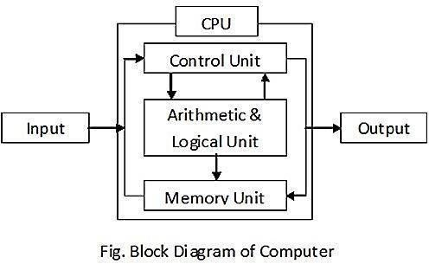

There are 3 basic functional units in a digital computer. They are,

* 1. Input Unit
  2. System Unit
  3. Output Unit

**Input Unit:** Input unit is an external device that is connected to the CPU. It is used to feed data and instructions for solving the problem at hand. The Control Unit sends signals to this unit to receive data and instructions from the user, this data and instructions are communicated to the CPU. Some of the important input devices are: 1] Keyboard 2] Mouse 3] Joystick 4] LightPen 5] Trackball 6] Optical Scanner 7] Digitize 8] Microphone Input **Devices:**

The device that accepts data from the user and communicates it to the CPU is called an input device. There are variety of input devices. Some of them are discussed below.

|  |  |
| --- | --- |
| **1] Keyboard :** | It is the most common input device it is used to enter both numerical and character type data. It is like a mechanical typewriter with alphanumeric and special Keys. All IBM compatible Keyboards contain 101 Keys. Keyboards with 84 Key are also available. |
| **2] Mouse :** | It is a small hand held pointing device connected to the CPU through a cable. It has rotating ball at the bottom and has two click buttons on the top. It controls the cursor and move the pointer in the same direction as the mouse.  The arrow point is called mouse pointer. |
| **3] Scanner :** | It is an input device. It is used to acquire (scan) both character and graphics required for image processing or character recognition. Sensors are used in scanners. Flatbed scanner is the most commonly used scanner. The scanner is connected to the CPU from outside. |

**System Unit:** Once the data and instructions are received from the input unit they are stored and processed in the

system unit. The system unit further consists of mainly two sub-units. They are:

1. Central Processing Unit
2. Memory Unit

**1] Central Processing Unit:** This is generally called the CPU. Once the data and instructions are received from the input device, they are to be processed in this unit. So, it can be considered as the heart and brain of the computer system. CPU consists of two important functional units.

##### Control Unit

1. **Arithmetic & Logic Unit**

**Control Unit:** The control unit co-ordinates all the activities of the computer and instructs the computer system to carry out the programs. It directs the control signals between the CPU, input and output device.

##### The following are some of the functions performed by the control unit:

* + Fetching data & instructions from the main memory
  + Interpreting these instructions
  + Controlling the transfer of data and instructions to and from the main memory
  + Controlling input and output devices
  + The overall supervision of computer system

1. **Arithmetic and Logic Unit:** ALU performs arithmetic, logic and comparison functions. Arithmetic operations consist of addition, subtraction, multiplication and division. Logic operation include the comparison of data so as verify it to be greater than, smaller than or equal to the other data.
2. **Memory Unit:** Memory is an important part of a computer that stores the program or data that is under process that is to be processed or it is already processed. The memory capacity differs from computer to computer. In modern computers, a memory can store billions of instructions or characters, whereas an IBM PC can hold 6, 40,000 characters.

##### Computer memory is classified into:

1] Main Memory 2] Secondary Memory 3] Cache Memory

**1] Main Memory:** This is the place where the data and instructions supplied by the input devices are stored. This is a temporary memory because the data and instructions stored here are erased when the power goes off. This is also referred to as the primary memory. It consists RAM and ROM memories.

##### RAM:

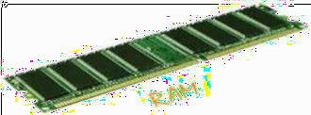

This is the short form of Random Access Memory. It is the read and write memory. The RAM chip is made of metal oxide semiconductor, therefore any memory stored in any memory location can be accessed directly without scanning it sequentially. Because of this, it is called random access memory. It is a temporary memory because during power failure, the information stored in RAM will be erased. Sometime it is called volatile memory.

**ROM:**

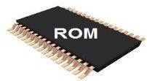

##### 

This is the short form of Read Only Memory. It is a permanent memory. That is, the information stored in it will not be lost even if the power goes off. It sores mainly monitor program and BIOS programs. The information stored in it can only be read. The contents of ROM cannot be changed. But, it can be programmed under special conditions. It is a manufacturer programmed memory

**2] Cache Memory:** This is a high speed memory and placed between the CPU and the main memory. The data and instructions stored in it are accessed at a higher speed as compared to the main memory. Users cannot access this memory. It stores data and instructions that are currently to be executed.

##### 3] Secondary Memory: [Auxiliary Storage Devices]

It is very difficult to enter the data and instructions for a large application again and again. Therefore, it is necessary to store the data permanently for future usage. Data can be stored permanently on secondary storage devices and the data can be retrieved whenever required. The secondary storage devices are also called *Auxiliary Storage Devices*. **The most commonly used secondary storage devices are:**

|  |  |
| --- | --- |
| **Floppy Disk:** A floppy disk, also called a floppy, diskette, or just disk, is a type o[f](https://en.wikipedia.org/wiki/Disk_storage) [disk storage c](https://en.wikipedia.org/wiki/Disk_storage)omposed of a disk of thin and flexible [s](https://en.wikipedia.org/wiki/Magnetic_storage)torage medium, sealed in a rectangular plastic enclosure lined with fabric that removes dust particles. Floppy disks are read and written by a floppy disk drive (FDD). |  |
| **Hard Disk:** When you save data or install programs on your computer, the information is typically written to your hard disk. The hard disk is a spindle of magnetic disks, called platters, that record and store information. Because the data is stored magnetically, information recorded to the hard disk remains intact after you turn your computer off. This is an important distinction between the hard disk and [RAM,](https://techterms.com/definition/ram) or memory, which is reset when the computer's power is turned off. |  |
| **CD ROM:** Short for Compact Disc-Read Only Memory, a CD-ROM(shown right) is an [optical disc w](https://www.computerhope.com/jargon/c/compactd.htm)hich contains audio or software data whose memory is [read only.](https://www.computerhope.com/jargon/r/readonly.htm) A CD-ROM Driver optical drive is the device used to read them. CD-ROM drives have speeds ranging from 1x all the way up to 72x, meaning it reads the CD roughly 72 times faster than the 1x version. As you would imagine, these drives are capable playing audio CDs and reading data CDs. |  |
| **Dvd: Digital Video Disk**  DVD is an optical disc technology with a 4.7 gigabyte storage capacity on a single sided, one-layered disk, which is enough for a 133-minute movie. DVDs can be single- or double-sided, and can have two layers on each side; a double-sided, two layered DVD will hold up to 17 gigabytes of video, audio, or other information. This compares to 650 megabytes (.65 gigabyte) of storage for a CD-ROM disk. |  |

**Output Unit:** This is used to display the results obtained after execution of a program. Whenever the user wants output from the computer, the control unit sends signal to this unit to be ready to accept processed data from memory and to display it. The following are various output devices.

1. Monitor 2] Printer 3] Plotter 4] Speakers 5] Plasma Display panel 6] LCD display

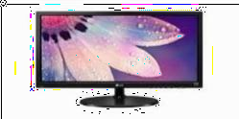

**Monitor :** The monitor is the piece o[f computer hardware t](https://www.lifewire.com/computer-hardware-2625895)hat displays the video and graphics information generated by the computer through the [video card.](https://www.lifewire.com/what-is-a-video-card-2618161) Monitors are very similar to televisions but usually display information at a much higher resolution.

|  |  |
| --- | --- |
| **Printer:** A printer is an [external](https://www.computerhope.com/jargon/e/external.htm) [h](https://www.computerhope.com/jargon/e/external.htm)ardware [o](https://www.computerhope.com/jargon/o/outputde.htm)utput devic[e](https://www.computerhope.com/jargon/o/outputde.htm) [t](https://www.computerhope.com/jargon/o/outputde.htm)hat takes the  electronic data stored on a computer or other device and generates a [hard](https://www.computerhope.com/jargon/h/hardcopy.htm) [copy of](https://www.computerhope.com/jargon/h/hardcopy.htm) it. For example, if you created a report on your computer you could print several copies to hand out at a staff meeting. Printers are one of the most popular computer peripherals and are commonly used to print text and photos. |  |
| **Plotter:** A plotter is a computer hardware device much like a printer that is  used for printing [vector graphics. I](https://www.computerhope.com/jargon/v/vector-graphic.htm)nstead o[f toner,](https://www.computerhope.com/jargon/t/toner.htm) plotters use a pen, pencil, marker, or another writing tool to draw multiple, continuous lines onto paper rather than a series of dots like a traditional printer. Though once widely used fo[r computer-aided design,](https://www.computerhope.com/jargon/c/cad.htm) these devices have more or less been phased out by wide-format printers. Plotters are used to |  |
| Produce [a hard copy of](https://www.computerhope.com/jargon/h/hardcopy.htm) schematics and other similar applications. |  |
| **Speaker:** A computer speaker is a [hardware device](https://www.computerhope.com/jargon/h/hardware.htm) [t](https://www.computerhope.com/jargon/h/hardware.htm)hat connects to a  computer to generate sound. The signal used to produce the sound that comes from a computer speaker is created by the computer's [sound card.](https://www.computerhope.com/jargon/s/souncard.htm) |  |

**Printers:** Printer is an output device that prints the programs, illustrations etc. from the computer on the paper and transparencies.

A printer is an electromechanical device which receives signals from the computer and acts accordingly.

##### Classification of Printers:

|  |  |
| --- | --- |
| **Dot Matrix Printer:** Dot matrix printing or impact matrix printing is a type of computer printing which uses a print head that moves back-and-forth, or in an up-and-down motion, on the page and prints by impact, striking an inK-soaKed cloth ribbon against the paper, much like the print mechanism on a |  |
| **Daisy Wheel Printer:** A daisy wheel printer is an early type o[f](https://www.computerhope.com/jargon/i/impaprin.htm) [impact Printer](https://www.computerhope.com/jargon/i/impaprin.htm) invented in [1969 b](https://www.computerhope.com/history/1969.htm)y David S. Lee at Diablo Data Systems. The printer uses a metal or plastic disk containing each of the letters, numbers, and other characters it supports. When something is printed, the printer rotates the disk to each character and then using a hammer strike each character into an ink ribbon to create the character on paper. |  |
| **Plotter:** A plotter is a computer hardware device much like a printer that is used for printing [vector graphics.](https://www.computerhope.com/jargon/v/vector-graphic.htm) Instead o[f toner,](https://www.computerhope.com/jargon/t/toner.htm) plotters use a pen, pencil, marker, or another writing tool to draw multiple, continuous lines onto paper rather than a series of dots like a traditional printer. Though once widely used for computer aided these devices have more or less been phased out by wide-format printers. Plotters are used to produce a [hard copy](https://www.computerhope.com/jargon/h/hardcopy.htm) [of](https://www.computerhope.com/jargon/h/hardcopy.htm) schematics and other similar applications. |  |
| **Laser Printers:** A laser printer is a popular type of personal computer [printer](http://whatis.techtarget.com/definition/printer) that uses a non-impact (Keys don't strike the paper), photocopier technology. When a document is sent to the printer, a laser beam "draws" the document on a selenium-coated drum using electrical charges. After the drum is charged, it is rolled in toner, a dry powder type of ink. The toner adheres to the charged image on the drum. The toner is transferred onto a piece of paper and fused to the paper with heat and pressure. After the document is printed, the electrical charge is removed from the drum and the excess toner is collected. Most laser printers print only in monochrome. A color laser printer is up to 10 times more expensive than a monochrome laser printer. |  |
| **Inkjet Printer:** An inkjet printer is a computer [peripheral t](http://searchmobilecomputing.techtarget.com/definition/peripheral)hat produces [hard copy](http://whatis.techtarget.com/definition/hard-copy-printout)  by spraying ink onto paper. A typical inkjet printer can produce copy with a [resolution of](http://searchcio-midmarket.techtarget.com/definition/resolution) at least 300 dots per inch [( dpi ).](http://whatis.techtarget.com/definition/dots-per-inch-dpi) Some inkjet printers can make full color hard copies at 600 dpi or more. Many models include other devices such as a [scanner , photocopier ,](http://whatis.techtarget.com/definition/scanner) and dedicated [f](http://searchnetworking.techtarget.com/definition/fax)ax machine along with the printer in a single box. |  |

**Software:**

Software is a collection of programs. Program is a set of commands. Command is an instruction given to the computer to perform specific task. Software are broadly classified into two types. Those are, 1] Application Software 2] System Software

1. **Application Software:** This is a general purpose program or a collection of programs written by the users to solve a particular problem. For example, Payroll, Inventory system, Student Information System, Library

Management System, Hotel and Hospital Management System, etc., are the applications. Anybody who Knows programming languages and has problem solving capability, can write the application software. Examples of application software’s are: MSOffice, PageMaker, Corel Draw, Photoshop, Tally, Nudi etc.

1. **System Software:** This is a collection of programs written for computer system management. These programs are developed by the manufacturer. They are supervisory programs and help in executing the user’s programs effectively. We can classify system software into the following three types. 1) Operating System 2) Language Processors 3) System Utilities **Operating System:** This is an integrated collection of programs which make the computer operational and help in executing user programs. It acts as an interface between the man and machine. It manages the computer system resources such as memory, processors, input-output devices and files. Without an operating system, the most powerful computer a useless monster. Therefore, an operating system is a must for a computer to do any tasks.

##### The functions of operating system are given below.

1. **Memory Management**: Allocating memory to the running programs and de-allocating when they are terminated.
2. **Processor Management:** Processing the jobs, deciding on the job scheduling technique and how long a job is to be processed. Releasing the processor when the jobs are terminated.
3. **Device Management:** Allocating the input and output devices to the running processes and de-allocated them when the processes are terminated.
4. **File Management:** Managing the file system in terms of where the files are stored, their status and memory locations. Opening and closing the files. Providing access permissions to the files.

There are different types of operating systems available today. Those are, DOS, Unix, Windows95, Windows 98, Novel Netware, Windows NT, Windows 2000, Linux, Windows XP etc.,

##### THE WINDOWS OPERATING SYSTEM

Every computer needs an operating system which lets you, literally, operate your computer. There are a few around and Microsoft Windows is just one of them, albeit one of the most popular ones. Some of the functions the Windows operating system allows you to do are:

* Access applications (programs) on your computer (word processing, games, spread sheets, calculators and so on)
* Load any new programs on to the computer
* Manage hardware such as printers, scanners, mouse, digital cameras
* Manage how files are stored on your computer (File Management, covered later in this module)
* Change computer settings such as color schemes, screensavers, and the resolution of your monitor.

The operating system is what allows you as the user to access the information in the computer. To understand how to use a computer, it is important to know several features of the Windows system.

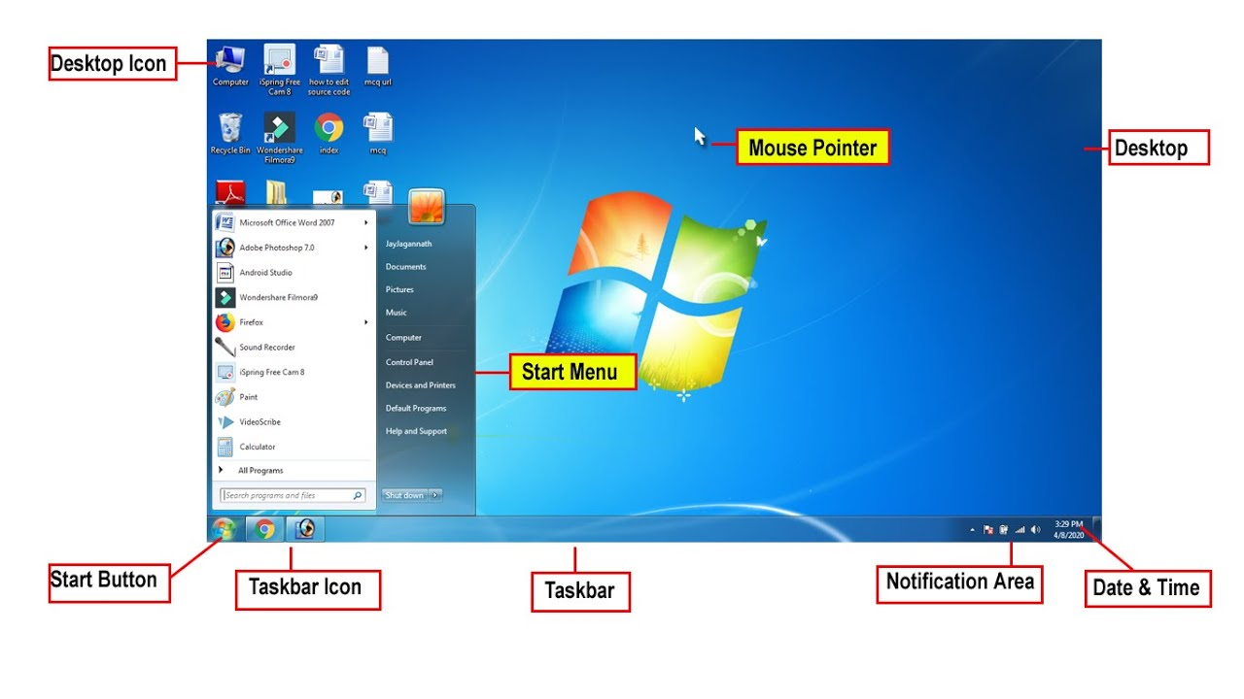**Desktop:** The desktop is the area you see when the computer is not running applications. It consists of the icons on top of it, as well as the Start button and other features. The desktop can be used to temporarily store information or to move around documents and windows.

**Icon:** Icons are little pictures that represent different programs or saved items on Desktop information icons represent.

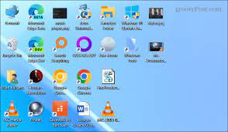

**Window**: Recycle Bin is windows default icon which can store all deleted Files

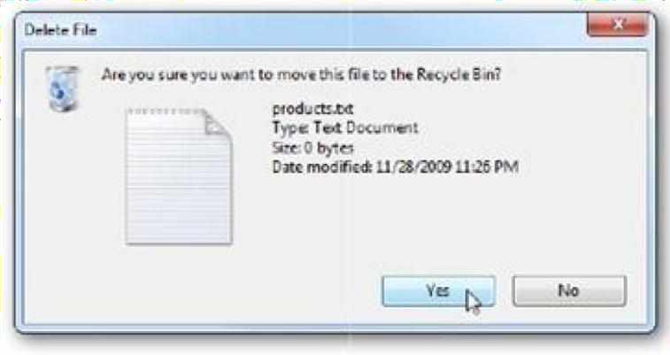

**Dialogue Box:** You ask the computer to do certain commands, such as to save your work, the computer will need more Information from you, and this will appear in a dialogue box. These boxes contain options and commands for the computer to execute.

##### Start Menu:

In the lower left the Start button. When you click on the button a menu will appear, which we will call the Start menu. This menu gives you access to all the different parts and functions of the computer.

**Task Bar**: At the very bottom of the screen is a horizontal bar called the task bar. This bar contains (from left to right) the Start button, shortcuts to various programs, minimized programs, and another section of shortcuts that includes sound volume, printers and the time.

##### Windows Exercises

* 1. **Change the Date and Time of the Computer *Lab Solution Steps:***

1. 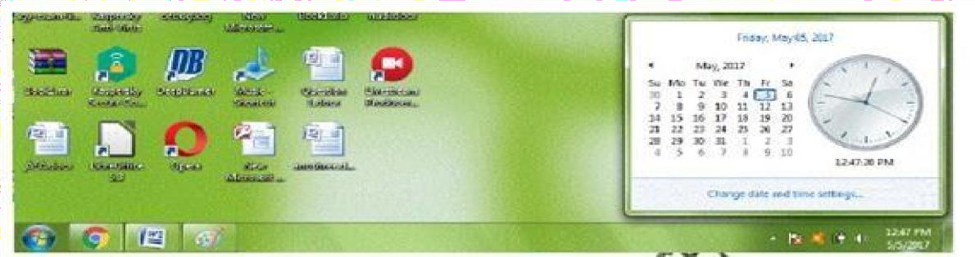Click on Date and Time (Task bar Right Bottom Side)
2. Click on Change date and Time Settings



1. You will get Date and Time

Dialog Box ->Click on Change Date and Time Button

1. Change the Date and Time-> Click OK Button

**2) Add Clock Widget on Desktop *Lab Solution Steps:***

1. Right Click on Desktop ->Click on Gadgets

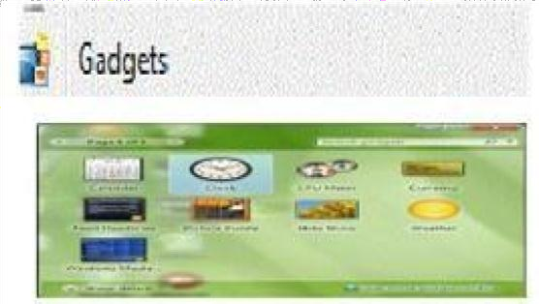 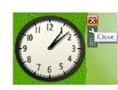

1. Select the Clock and Press Enter Key ***Or*** Double Click on Clock
2. **Remove Clock Widget from Desktop *Lab Solution Steps :***

1) Move the mouse over the Clock ->Click on Close Button

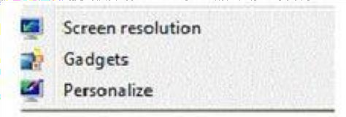**4) Change the Wallpaper** *Lab Solution Steps:*

1. Right Click on Desktop ->Click on Personalize
2. Click on Desktop Background

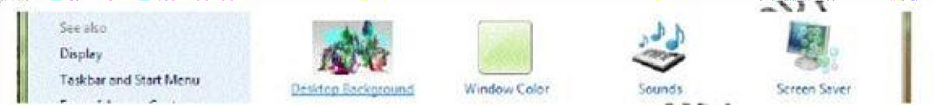

1. Select the Image-> Click on Save Changes

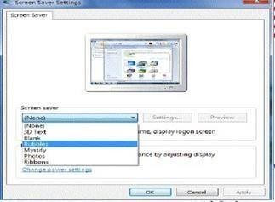**5) Change the Windows Theme** *Lab Solution Steps:*

1. 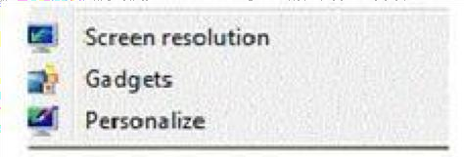Right Click on Desktop -> Click on Personalize
2. Click on the Theme

**6) Set Bubble Screen Saver** *Lab Solution Steps:*

1. Right Click on Desktop -> Click on Personalize
2. Click on Screen Saver
3. Select the Bubbles-> Click on apply Button ->Click on OK Button

##### 7) Open the Calculator and Pin in it in Task bar

###### Lab Solution Steps:

1. Click on Start Button ->All Programs -> Accessories->Calculator

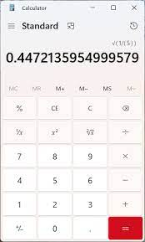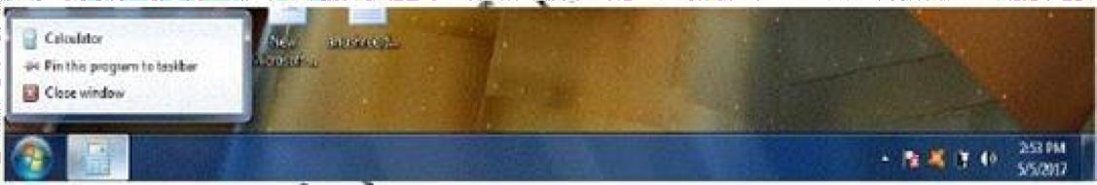

1. Right Click on the Calculator Icon (In Task Bar)->click on Pin this program to taskbar

**8) Un Pin Calculator from Task bar *Lab Solution Steps:***

1. 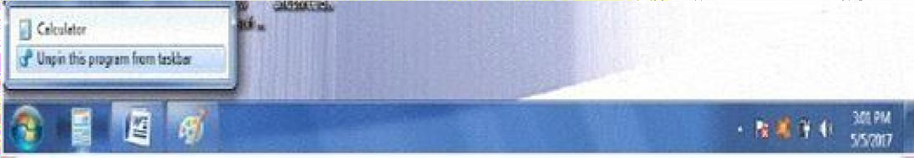Right Click on the Calculator Icon(In Taskbar)-> click on Unpin this program from taskbar

**9) Create a Folder “KEONICS” in D Drive *Lab Solution Steps:***

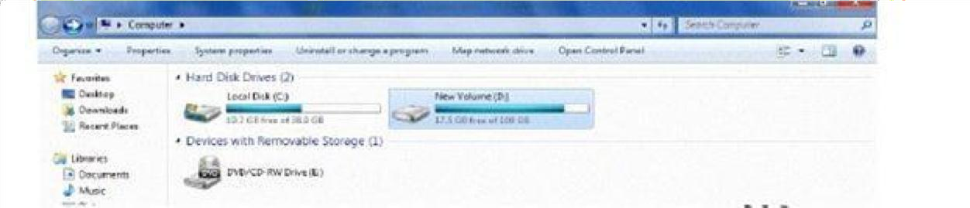Start Button -> My Computer -> Double Click on D Drive

1. Right Click--- Select on new Folder Button -> Enter your Folder Name -> Press Enter Key or Click out side

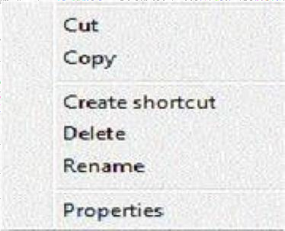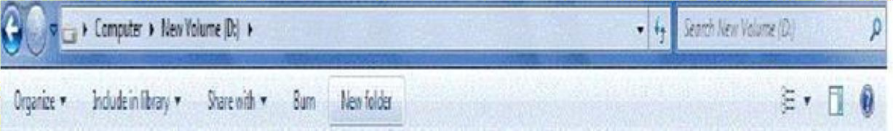

1. **Rename “KEONICS” Folder to “KTC Hubli” *Lab Solution Steps:***
2. Right Click on the Folder -> Type the new name ->Press Enter Key or Click out side
3. **Cut “KTC Hubli” Folder and Paste it on Desktop *Lab Solution Steps:***
4. Right Click on the Folder -> Click on Cut
5. Minimize the Window
6. Right Click on Desktop -> Click on Paste

##### 3. Copy “KTC Hubli” Folder and Paste it in D Drive

###### Lab Solution Steps:

1. Right Click on the Folder which is on Desktop
2. Click on Copy
3. Open D Drive
4. Right Click
5. Click on Paste

##### M.S.Paint

**Microsoft Paint** is also known as **MS Paint**. It is a basic graphics drawing program that has been an indispensable part of all versions of the Microsoft

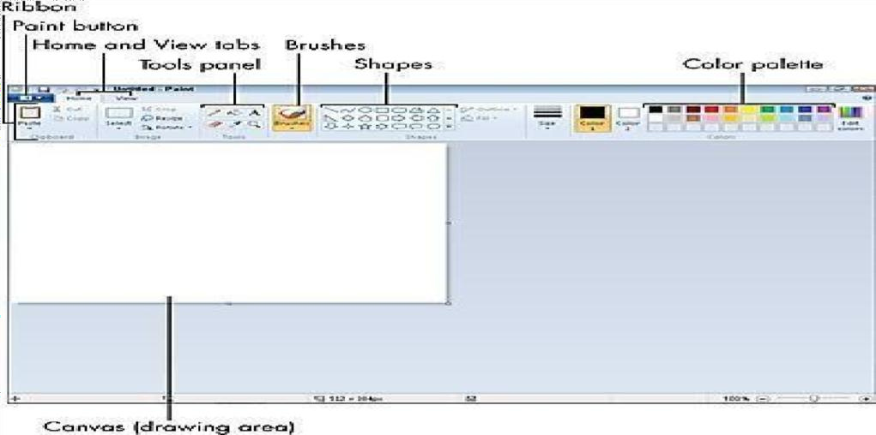Open the Windows Start menu -> Select All Programs Click on Accessories-> Select Paint

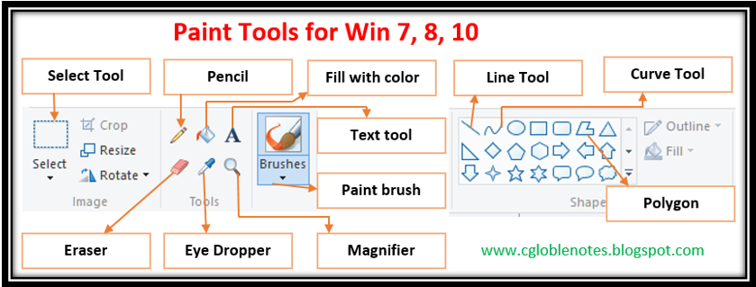

**Saving File:** File ->Save As ->Type your File Name (Example: KEONICS-Hubli) -> Save

##### Notepad

**Notepad** is a simple text editor for Windows; it creates and edits plain text documents.Notepad is a handy program that a user can type in text quickly and easily. It is not for publishing a book but more of a scratchpad.  
 To open Notepad click on start -> All Programs -> Accessories -> Notepad

**Note :**

To enter text, just start typing in Notepad

**To Save** Your work click on File > Save button > Give the name for file

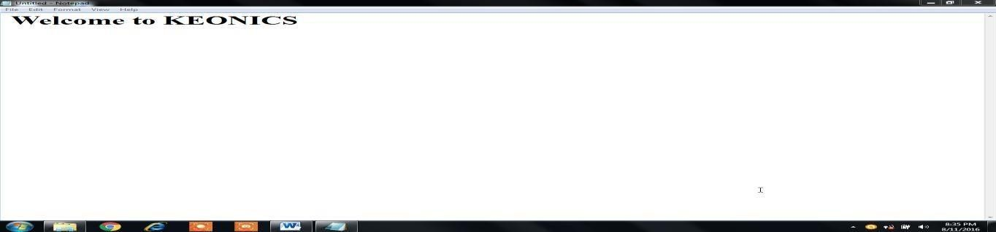

**WordPad  
WordPad** is the basic word processor that has been included with almost all versions of Microsoft Windows

**Starting a WordPad:** Click On start Button Click on All Programs Click On Accessories WordPad

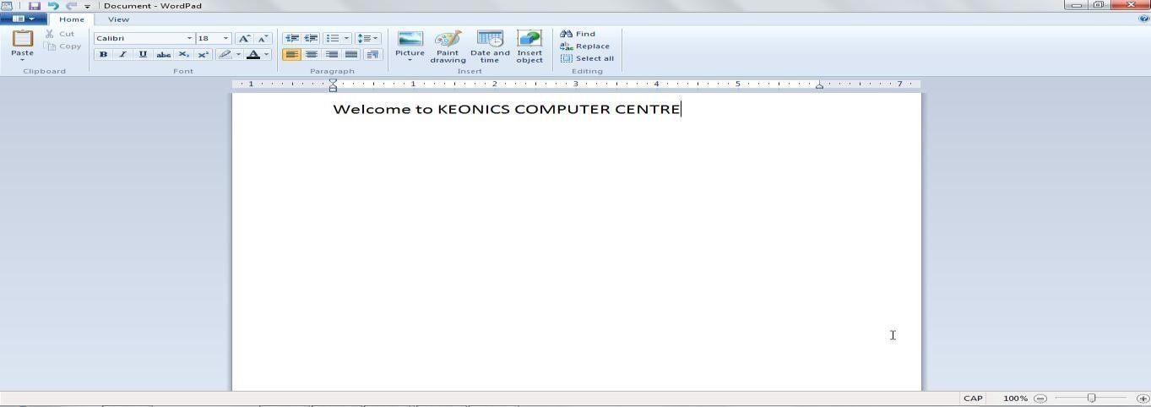

#### Microsoft Office

#### MS Office is a application software which was developed by Microsoft Corporation in 1988. This Office suite comprises various applications which form the core of computer usage in today’s world. Microsoft Office is a suite of desktop productivity applications that is designed specifically by Microsoft for business use. It is a proprietary product of Microsoft Corporation and was first released in 1990.

The Word, Excel and PowerPoint applications in Microsoft Office are familiar household names, even to people who are not familiar with the details of the Office suite’s evolution. They are often used by a diverse user base, for example, college students, interns, or front line workers in IT. By contrast, someone may use Word, Excel and PowerPoint frequently, and rarely or never use Access, Publisher or OneNote.

#### Following are the most used application of MS Office.

**1. MS Word**

* First released on October 25, 1983
* Extension for Doc files is “.docx”
* It is useful in creating text documents
* Templates can be created for Professional use with the help of MS Word

**2. MS Excel**

* Majorly used for making spreadsheets
* It is a data processing application
* Large data can easily be managed and saved in tabular format using MS Excel
* Calculations can be done based on the large amount of data entered into the cells of a spreadsheet within seconds
* File extension, when saved in the computer, is “.xlsx”

**3. MS PowerPoint**

* It was released on April 20, 1987
* Used to create audiovisual presentations
* Each presentation is made up of various slides displaying data/ information
* Each slide may contain audio, video, graphics, text, bullet numbering, tables etc.
* The extension for PowerPoint presentations is “.pptx”
* Used majorly for professional usage

#### MS Word

Microsoft Word is a word processing software package. You can use it to type letters, reports, and other documents. It gives you the ability to use your computer for desktop publishing.

##### Starting of MS-Office

Click on start Button ---Click on All Programs --- Click on MS-Office -----Click on MS Word

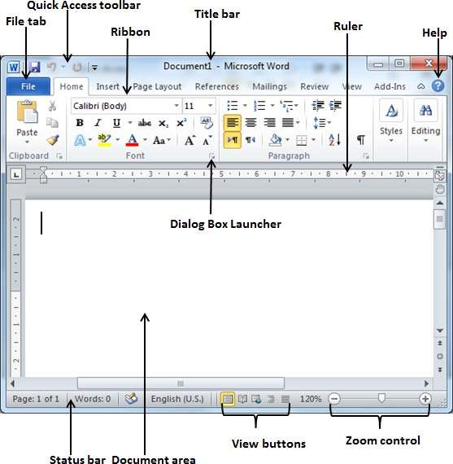

##### About Office Button or File Menu:

**The following options are** **in Office Button/File Menu:**

New [Ctrl+ N] Open [Ctrl+ O] save [Ctrl+ S]

Save as [F12] Print [Ctrl+ P] Send Exit

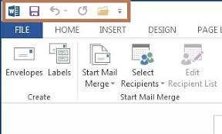**Quick Access Toolbar** is a toolbar menu that appears in Microsoft Excel, Microsoft Word, and other Office 2007 in the top left corner of the window. As seen in the picture, the Quick Access Toolbar gives you quick access to commonly used features such as the Save feature. Clicking on the Quick Access Toolbar down arrow gives you the ability to customize the Quick Access Toolbar and add and remove any of the commands shown in the toolbar.

**Tabs**:   
  
Microsoft Word is a powerful program that is used to create many different types of documents, including articles, letters, books, contracts, marketing documents, and much more. Microsoft Word has hundreds of *commands* for working with documents. To make it easier for users to find the specific commands they are looking for, commands are organized onto seven main tabs:

1. **HOME.** The HOME tab includes commands for formatting documents.
2. **INSERT.** Use the INSERT tab to insert pages, tables, pictures, links, headers and footers, custom text and symbols, and more.
3. **PAGE LAYOUT**. Use the PAGE LAYOUT tab to change your margins, add columns, change the page orientation, and more.
4. **REFERENCES.** Use the REFERENCES tab to add a table of contents, add footnotes, add a bibliography, and more.
5. **MAILINGS.** Use the MAILINGS tab to create labels, start a mail merge, and more.
6. **REVIEW.** Use the REVIEW tab to check spelling and grammar, track and accept or reject changes, compare Documents, and more.
7. **VIEW.** Use the VIEW tab to change your document view, show the Ruler or navigation pane, zoom in or out, and more.

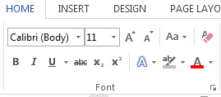

Click on This Icon for Font Dialog box or use Short cut Key control + D

**This is Bold** Select the text and click on



*This is Italic* Select the text and click on

This is Underline Select the text and click on

~~This is strike~~ Select the text and click on

We need H2O Select the Number 2 and click on

This is Math’s 102 Select the text and click on

**Applied Text Effect** Select the text and click on

This is blue colored text Select the text and click on

This text is highlighted Select the text and click on

**Sentence case** is applied for the line Select the text and click on

This is **lower case** text Select the text and click on

This is **upper case** text Select the text and click on

**Capitalize each word** Select the text and click on

**Toggle case** is applied for this line Select the text and click on

Increase Font Select the text and click on

Decrease Font Select the text and click on

This font size is **28** Select the text and click on

This font is Times New Roman Select the text and click on

**B** Button

Button

**U** Button

Button Button Button Button

Button Button Button

Button Button Button Button

Button

Button Button

Button

***Using Font Dialogue Box*** Select the text and click on **B**

**U** Button

Selecting a font and font style Font: Times New Roman, Font Size: 16, Apply Bold

Selecting a font & Choosing a font Font: Monotype Corsiva, Font Size: 16, Apply Italic

Applying Underline Style Font: Algerian, Font Size: 16, Apply Underline

T h i s i s e x p a n d e d t e x t **Go To Font Dialogue box Advanced Spacing Expanded 6pts**

This is condensed text **Go To Font Dialogue box Advanced Spacing Condensed 2pts**

##### We need H2O Go To Font Dialogue box Advanced Position Lowered 4pt

This is Math’s 102 **Go To Font Dialogue box Advanced Position Raised 4pt**

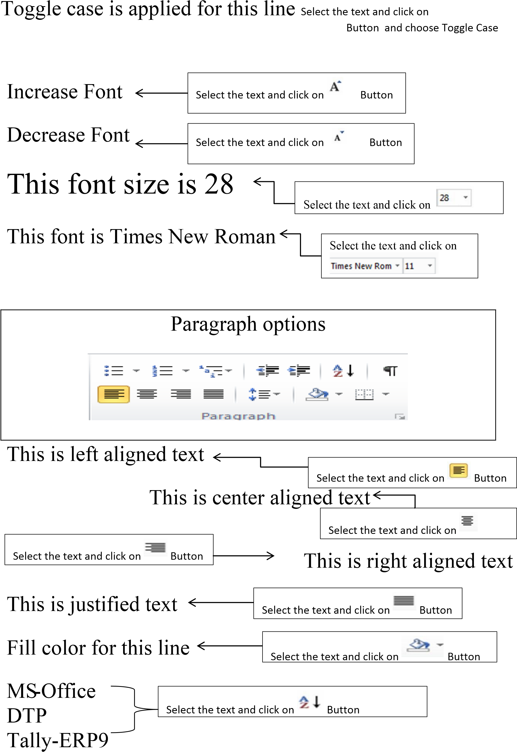

**Bullets & Numbering**

**Steps to save files**



**TYPES OF BULLETS**

|  |  |  |
| --- | --- | --- |
| * Keyboard * Mouse * CPU * Monitor * Printer | * Windows * Linux * Unix * Mac * Android | * word * Excel * Power Point * Tally * Internet |

 Go to file or Click on Office Button or Press Ctrl + S.

 Click on Save or Save as Select the folder or drive.

 Type the file name.

 Click on Save

**Steps to open file**

* 1. Go to file or Click on Office Button or Press Ctrl + O.

|  |  |  |
| --- | --- | --- |
| 1. Motherboard 2. Hard disk 3. DVD 4. SMPS 5. Processor | 1. Memory 2. RAM 3. ROM 4. Pen Drive 5. CD | 1. DTP 2. PageMaker 3. Corel draw 4. Photoshop 5. Nudi |

* 1. Click on Open
  2. Select the file from folder or drive.
  3. Click on Open

**Steps to print file**

* + 1. Prepare a letter
    2. Go to file or Click on Office Button
    3. Click on Print or Press Control + P Button
    4. Select the required setting
    5. Click on Print option

## Tables

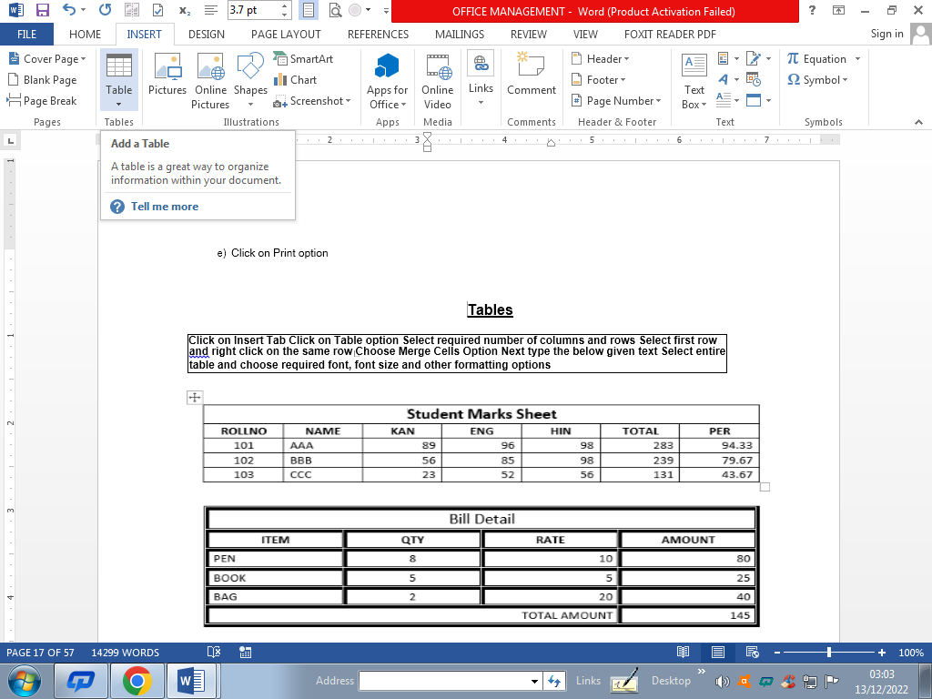

**Click on Insert Tab Click on Table option Select required number of columns and rows Select first row**

**and right click on the same row Choose Merge Cells Option Next type the below given text Select entire table and choose required font, font size and other formatting options**

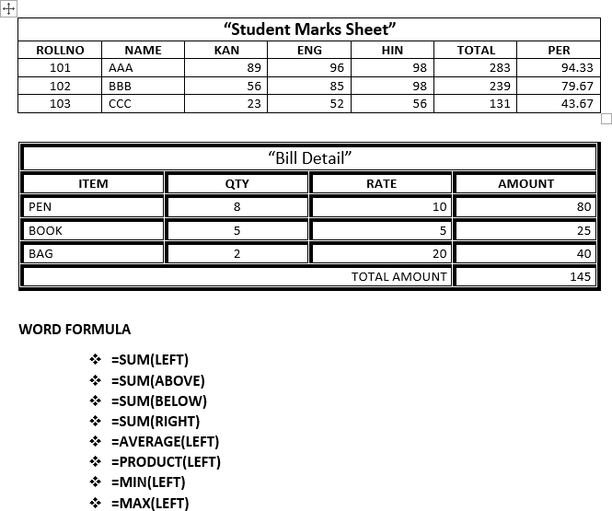

|  |  |  |
| --- | --- | --- |
| **BIG BAZAR GOKUL ROAD HUBLI** | | |
| **ITEM** | **STOCK** | **RATE** |
| PEN | 500 | 10 |
| BOOK | 1000 | 35 |

|  |  |  |  |  |  |  |  |  |  |
| --- | --- | --- | --- | --- | --- | --- | --- | --- | --- |
| Image result for keonics logo | | | **ಕಿಯಾನಿಕ್ಸ್ ಕಂಪ್ಯೂಟರ್ ತರಬೇತಿ ಕೇಂದ್ರ**  **(ಕರ್ನಾಟಕ ಸರಕಾರದ ಒಂದು ಉದ್ಯಮ)**  **ಶ್ರೀ ಗಾಳಿ ದುರ್ಗಮ್ಮ ದೇವಸ್ಥಾನದ ಹತ್ತಿರ, ಐಟಿ ಪಾರ್ಕ, ಹೊಸೂರು, ಹುಬ್ಬಳ್ಳಿ-29**  **KEONICS COMPUTER TRAINING CENTRE**  **(A Govt. of Karnataka Enterprise)**  **Near Shree Gaali Durgamma Temple, IT PARK, Hosuru, HUBBALLI-29**  **50% Discount for SC/ST** | | | | Related image | | |
| **Course**  **Code** | **Course Name** | | **Course Details** | | | **Course Duration** | **Fees For**  **GM** | **Fees For**  **SC/ST** |
| ADCA | Advance Diploma In Computer Application | | Basics of Computer, MS-Office, Kannada Nudi, DTP (PageMaker, Corel Draw, Photoshop), Tally With GST, C, C++, Java, Oracle, HTML, CSS, Java Script | | | 12  Months | 9876 | 5038 |
| DICFA | Diploma In Computer Financial Accounting | | **OM:** Basics of Computer, MS-Office (Word, Excel, PowerPoint), Kannada Nudi,  **Tally:** Fundamentals of Accounting, Introduction to Tally, Accounting Masters, Cost Centres & Cost Categories, Inventory Masters, Accounting Vouchers, Bill wise Details, Inventory Vouchers, Export & Import XML Data, GST, GSTR-1, GSTR2, POS Invoice, Reports | | | 6  Months | 5510 | 2855 |
| DICA | Diploma In Computer Application | | **OM:** Basics of Computer, MS-Office (Word, Excel, PowerPoint), Kannada Nudi,  **DTP:** Desktop Publishing (PageMaker, Corel Draw, Photoshop) | | | 6  Months | 5510 | 2855 |
| DIWD | Diploma In Advanced Web Designing | | HTML, CSS, Java Script, PHP, My SQL | | | 6  Months | 5982 | 3091 |
| DIAP | Diploma In Advanced Programming | | C, C++ and Java Programming | | | 6  Months | 5982 | 3091 |
| TALLY | Tally with GST | | Fundamentals of Accounting, Introduction to Tally, Accounting Masters, Cost Centres & Cost Categories, Inventory Masters, Accounting Vouchers, Billwise Details, Inventory Vouchers, Export & Import xml data, GST, GSTR-1, GSTR2, POS Invoice, Reports | | | 3  Months | 3504 | 1852 |
| OM | Office Management | | Basics of Computer, Internet, MS-Office (Word, Excel, PowerPoint), Kannada Nudi | | | 3  Months | 3504 | 1852 |
| CLC | Computer Literacy Course | | Basics of Computer, Internet, MS-Office (Word, Excel, PowerPoint), Kannada Nudi | | | 3  Months | 3504 | 3504  No Discount for SC/ST |
| AI with Python | Artificial Intelligence with Python | | Introduction, Python, Statistics, Linear Algebra and Calculus, Anaconda, Jupiter Notebook, NumPy Pandas and Matpolotlib, AI, ML, Deep Learning & Neural Networks, Computer Vision and Natural Language Processing and Mini Project | | | 4 Months | - | - |
| **Programming Courses** | | **Fees For**  **GM** | | **Fees For**  **SC/ST** | **BENEFITS**   * **Government Digital Certificate** * **Experienced Faculties** * **Good Infrastructure with Internet Facility** * **Professionally designed practical assignments** * **Training at your convenient hours** * **Placement Assistance** | | | |
| C- Programming | | 3504 | | 1852 |
| C++ Programming | | 3504 | | 1852 |
| **Documents Required to take admission:**  **1) 2-Photos 2) PUC marks card xerox 3) Aadhar card xerox 4) Caste certificate (Only for SC/ST Candidates)** | | | | | | | | |
| **For more details contact: 0836-2357675 Mr. Mahantesh Bannimarad 8296834510**  **Website:** [**www.keonics.in**](http://www.keonics.in) **and** [**www.keonicsx.com**](http://www.keonicsx.com) | | | | | | | | |



##### Applying Tab Settings

**Set tab 1”, 2”, 4”**

##### Roll No Name Address

1. Ajay Patel Hosur, Hubli
2. Chitin Jain Keshwapur, Hubli
3. Ganesh Habib Karwar Road, Hubli

**Preparing a simple calendar using Tab Options**

|  |  |  |  |  |  |  |
| --- | --- | --- | --- | --- | --- | --- |
| **Sunday** | **Monday** | **Tuesday** | **Wednesday** | **Thursday** | **Friday** | **Saturday** |
|  | 1 | 2 | 3 | 4 | 5 | 6 |
| 7 | 8 | 9 | 10 | 11 | 12 | 13 |
| 14 | 15 | 16 | 17 | 18 | 19 | 20 |
| 21 | 22 | 23 | 24 | 25 | 26 | 27 |
| 28 | 29 | 30 | 31 |  |  |  |

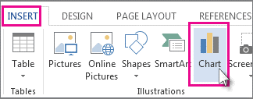

* **Chart Inserting**

**Marks**

120

100

80

60

Marks

40

20

0

Ajay

Basava

Raj

Kala

Ganesh

Steps To Insert Chart

* Go to insert Tab
* Click On Chart Icon
* Default Excel Sheet will be Open
* Enter the Data in Excel Sheet
* Automatically the entire data will be update into chart page

# RESUME

Insert Photo from Shape Fill picture

##### NiKhil V,

##### Email:niKi-V@gmail.com

**Personal Profile:**

Name : Nikhil V

Father’s Name : Mr. Naveen V

DOB : 01-01-2000

Gender : Male

Religion : Hindu

Marital Status : Unmarried

Computer Skill : MSO, Tally and DTP. Known Languages : Kannada, Hindi and English. Nationality : Indian

State : Karnataka

E-Mail ID : [NiKi-V@gmail.com](mailto:Niki-V@gmail.com)

Contact Number : 1234567890

Hobbies : Reading newspaper, Singing, Writing

Address : Electronic City   
 Bangalore

##### Academic Details:

|  |  |  |  |
| --- | --- | --- | --- |
| **Qualification** | **Name of the University/Board** | **Percentage** | **Year of**  **Passing** |
| SSLC | Karnataka Education Board, Bangalore | 75% | 2008 |
| PUC | Karnataka Education Board, Bangalore | 68% | 2010 |
| B.COM | Karnataka University | 80% | 2013 |

**STRENGTH:** Good Patience Skill, String Human Relation, Challenging Surveying Works,

##### DECLARATION:

I hereby declare that all the above information is true and correct best of my Knowledge and belief.

Place: **Hubli (Signature)**

**Date:** 01-01-0000 (NIKHIL V)

**Applying paragraph, Drop Cap, Inserting picture between paragraphs: newspaper Assignment.**

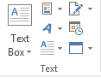

Select First Letter in paragraph go to insert tab click on drop cap option select dropped

Min: 1 lines Max: 10 lines

Default: 3 lines

rocess and gives results to the user. The term computer is derived from the Latin word compute which means to calculate or to manipulate. Therefore, the computer is a calculation machine. A computer can store any amount of data and instructions in its memory.

The computer’s memory is just like a human brain where information is stored and retrieved from. A computer receives the data and instructions from the user and displays it after the execution. Computer is an extremely fast information processing device it carries out all the instructions per second (MIPS). It gives accurate result for correct input data. Here accuracy means the correctness of the processed data. If the input data is erroneous, the output.

P

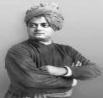It gives consistent results even though it runs on electrical

connections and electronic circuits which are often prone to errors.

Computers are used everywhere – be it scientific calculations,

business processing. They are used in teaching, training,



Wanted: some workers for good work

simulation, media and entertainment etc. It does not

feel tiered. It can also be used for a number of days or months nonstop. It will work satisfactorily without fatigue.

Video provides a powerful way to help you prove your point. When you click Online Video, you can paste in the embed code for the video you want to add. You can also type a Keyword to search online for the video that best fits your document. Video provides a powerful way to help you prove your point. When you

click Online Video, you can paste in the embed code for the video you want to add. You can also type a Keyword to search

online for the video that best fits your document.

Information Technology

To make your document look professionally produced, Word provides header, footer, cover page, and text box designs that complement each other. For example, you can add a matching cover page, header,



Video provides a powerful way to help you

and sidebar. Click Insert and then choose the elements you want from the different galleries. Themes and styles also help Keep your document coordinated. When you click Design and choose a new Theme, the pictures,

charts, and SmartArt graphics change to match your new theme. When you apply styles, your headings change to match the new

.

Save time in Word with new buttons that show up where you need them. To

.

.

change the way a picture fits in your document, click it and a button for layout options

appears next to it. When you work on a table, click where you want to add a row or a

column, and then click the plus sig

**Shapes & Word Art & Different type of Designs.**



**Click on Insert TabClick On Shapes Select Round Rectangle Draw rectangle as shown Below Choose Word Art Type Text Choose Proper Word Art Style Similarly Draw the Shapes as given below and type text**



**KEONICS COMPUTER CENTRE (A GOVT OF KARNATAKA ENTERPRISE), IT PARK, HUBBALLI PHNO: 0836-2367675 Pg. No: 21**

**Smart Art**

1. Click on Insert ta 🡺 Choose Smart Art 🡺Select Pyramid 🡺 **Type the below content**



2) Click on Insert ta 🡺 Choose Smart Art 🡺Select Cycle 🡺 **Type the below content**

3) Click on Insert ta 🡺 Choose Smart Art 🡺Select Hierarchy 🡺 **Type the below content**



**UPPER CASE**

**INTER OFFICE NOTE**

|  |  |
| --- | --- |
| **From:**  Assistant Manager Technical-Hubballi | **To :**  The Manager – ITED Bangalore |

Date: ………………….

Respected Sir,

Sub: Proposal to hire ERP data entry operator for 3 hours of work every day.

Due to over loaded work, I am unable to enter all students details in our online ERP portal. Therefore, I would like to hire ERP data entry operator for everyday 3 hours of online data entry work. Hence, kindly approve the proposal of an amount Rs 2000/ (Rupees Two Thousand Only) Per month to pay to the hired Data Entry Operator.

Yours faithfully, Assistant Manager – Technical

KTC - Hubballi

**Go to Insert Tab Symbol More Symbol Choose Font Style” Wingdings**

**Keonics Computer Training Centre**

**IT Park, Hubli**

✯✯✯✯✯✯✯✯✯✯✯✯✯✯✯✯✯✯✯✯✯✯✯✯✯✯✯✯✯✯✯✯✯

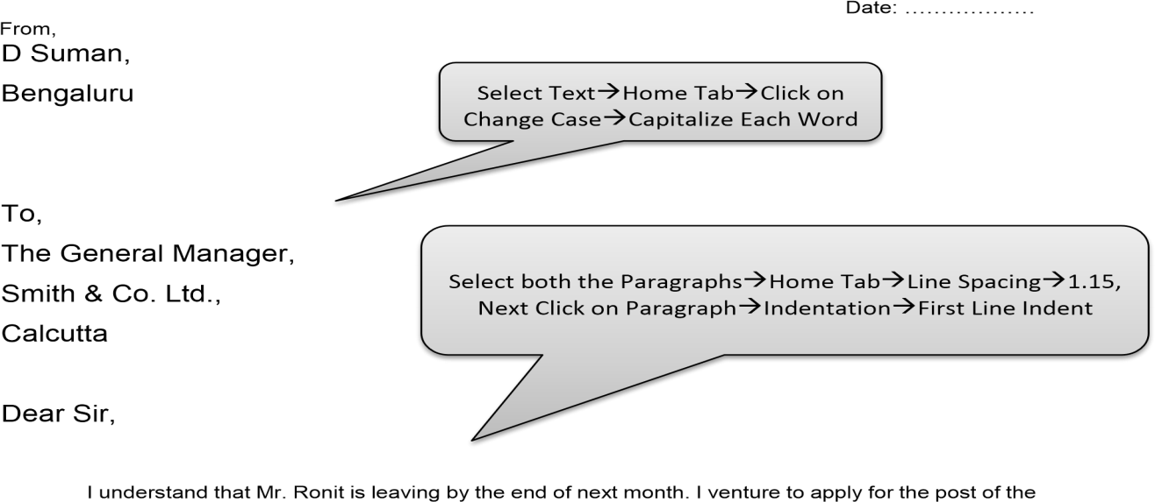

Senior clerk. I have been with this company for five years and three years were spent in working under Mr. Remit and I officiated in his place when he was away.

I Know the work of the senior clerk intimately and feel assured that could do the efficiently and to |

your full satisfaction.

Yours faithfully,

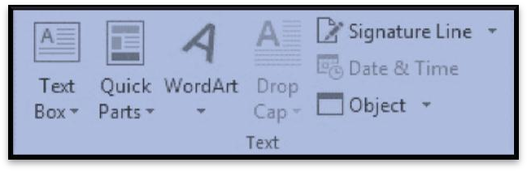01-01-0000

X

X

ABC

Manager

**INSERT TAB – SIGNITURE OPTION**

# Steps:

* 1. Go to Insert Tab select Word Art Type the Following.
  2. Go to Insert Tab select shape use shape fill option from format tab choose any color
  3. Go to Insert Tab select shape use shape fill option from format tab select picture click on insert button.
  4. Go to Page Layout tab page border option choose box art option choose the you want click on ok
  5. Go to Page Layout tab Water Mark option select text water mark type BIRTHDAY INVITATION click on ok
  6. Go to Page Layout tab page color option choose any color.
  7. Type the below text Select Entire Page Go to Home Tab Select Font Times art New Roman Font Size: 14 Line spacing 1.15
  8. Select all paragraph home tab Click on Paragraph Option choose indents and spacing tab select special option from indentation group select first line

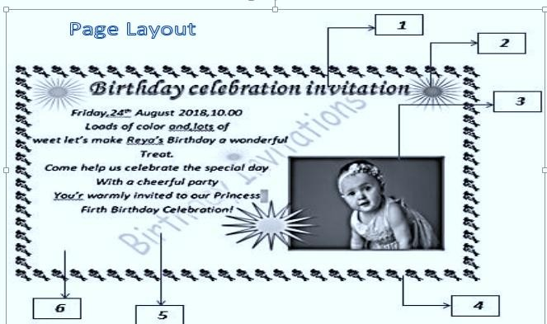

**REFERENCES TAB**

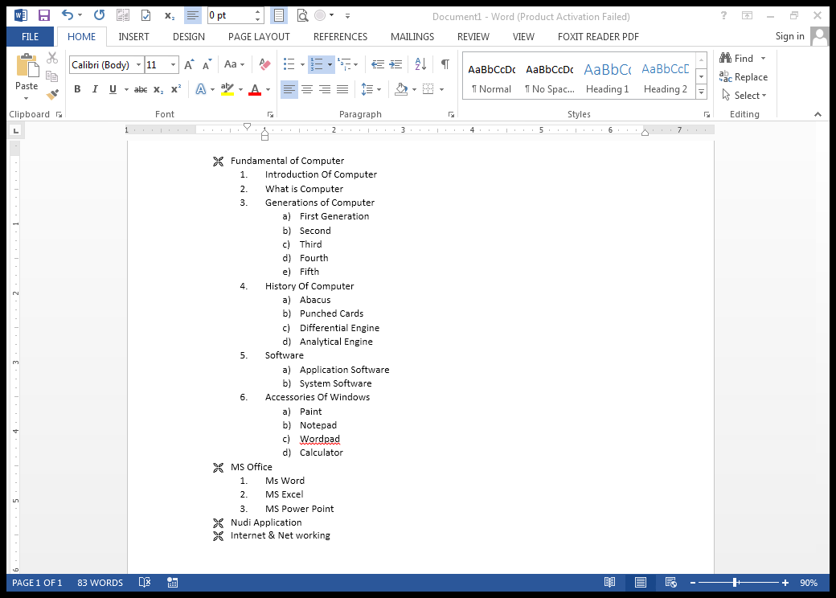

▪ It is use for create a table of contents

▪ Create a computerized booklets

▪ Create Bibliography / Author Details.

**Steps to Create a Booklet :-**

* 1. **Design First page by referring your assignment first page – Go to insert and select cover page**
  2. **Leave second page as blank later you should add Table of content**
  3. **Start to develop above list and text by using different types of Bullets, Number and Alphabets**
  4. **Go to Reference Tab and click on   
     Add Text option and add one after on like  
      Level -1 = Main heading  
      Level -2 = Sub heading  
      Level – 3 = Sub Option**
  5. **After Adding all heading Go to   
     Table of Content and add Automatic Table into 2 page**
  6. **Finally you will get automatic contents with page number**

**Note : want to add Reference and Bibliography you can add to content**

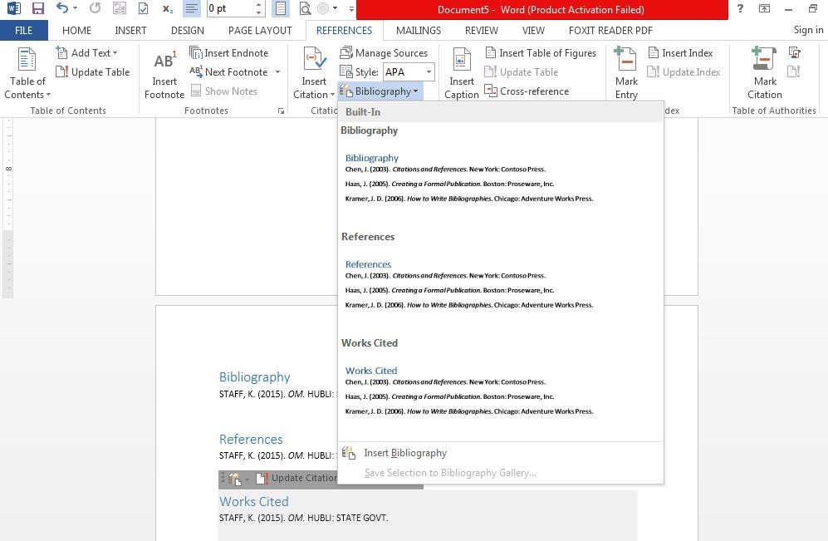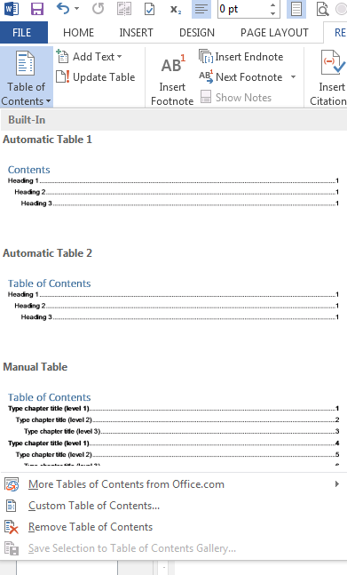

## Mailings:

### Go to Mailings Tab:

* 1. Click on select Recipients
  2. Type a new List
  3. New Address List
  4. Click on Customize columns
  5. Add or Delete Columns
  6. 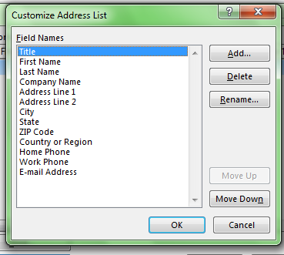Type There All Contact Details
  7. Save Your Address List
  8. Select Documents In
  9. Organize List
  10. Give File Name
  11. Save
  12. Create a Letter on Page
  13. Insert Address Block and
  14. Greeting Line in Your Letter
  15. Click on Preview Results

### Steps for Make a duplicate:

* 1. 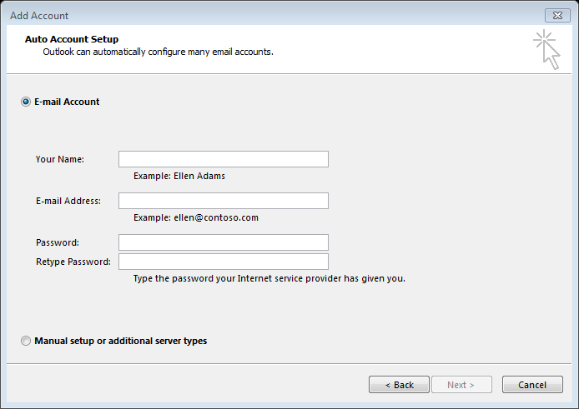Letter for other contacts
  2. Click On Finish & Merge
  3. Edit Individual Documents
  4. All
  5. OK
  6. Steps for open your address list
  7. Go to mailings tab
  8. Click On Select Recipients
  9. Use an Existing list
  10. Select Documents in
  11. Organize list
  12. Select Your File Name
  13. 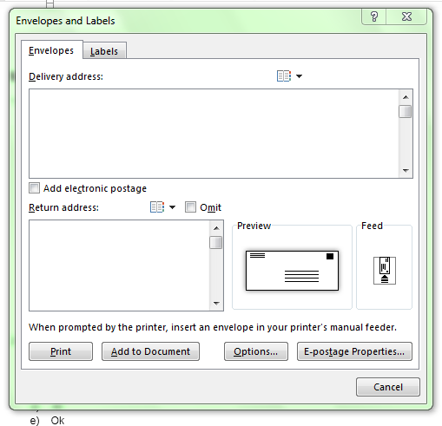Open
  14. Steps for sending E-Mail
  15. Message
  16. Click On Finish & merge
  17. Send Email Messages
  18. All
  19. OK
  20. Send any way
  21. Type there all your email
  22. Details
  23. Click on next

## Request Letter to Municipal Commissioner or Authority for Street Lights

Date: ………………..

To, Municipal Commissioner, Teacher’s Colony, Hubli

##### Sub: Letter to Municipal Commissioner for Street Lights

Respected Sir,

It is stated that I live in the far end building of the colony. I have been requesting for street lights to the building

Owner since some time now but he doesn’t seem to pay attention. That’s why I am writing this letter directly to you, requesting you to kindly take care of the street lights situation. As the sun sets the colony’s roads to become so dark that it’s almost impossible to see.

I hope that you will take this into concern as a priority very soon.

Thanking you,

##### Ajay Patel, Hubli Contact no: _____

## Student Leave Letter Format

**From,** date: 9/11/2019

|  |  |
| --- | --- |
| Student name | : Sushant Patel  : VI standard & „B‟ Section |
| Class & Section |
| Name of the parent | : Yashvant Patel |
| Address | : c/o S , Patel , 2nd cross, |
|  | Shanti Nagar, |
|  | Hubli |

##### To,

The principal,

Athena Global School, Hubli

**Sub:** Requesting for 3 days leave.

##### Sir,

My son could not attend the school from 11/11/2019 to 13/11/2019 due to health issues. So I request you to grant leave for the above days.

Thanking you,

Yours faithfully Signature of the parent

**Kannada Nudi**

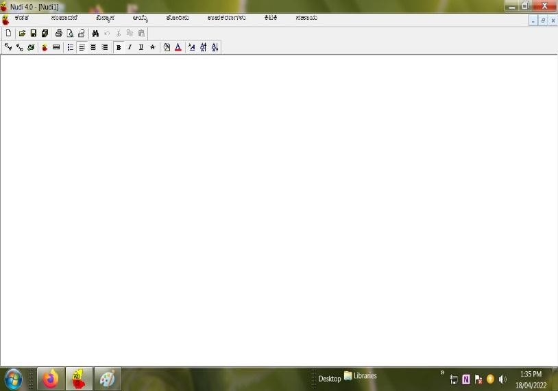Kannada Nudi is an Application Software → it is developed by Kannada Ganaka Parishat. (State Gov. of Karnataka)

**Applications: there are two Applications.**

1. Nudi
2. Nudi Direct.

#### Steps For To Open Kannada Nudi→

* Click on Start Button
* Go to All Programs
* Nudi 4.0 → Click on Nudi or Nudi Direct

#### Nudi Versions:

1. 2.0

2. 3.0 same versions 3. 4.0

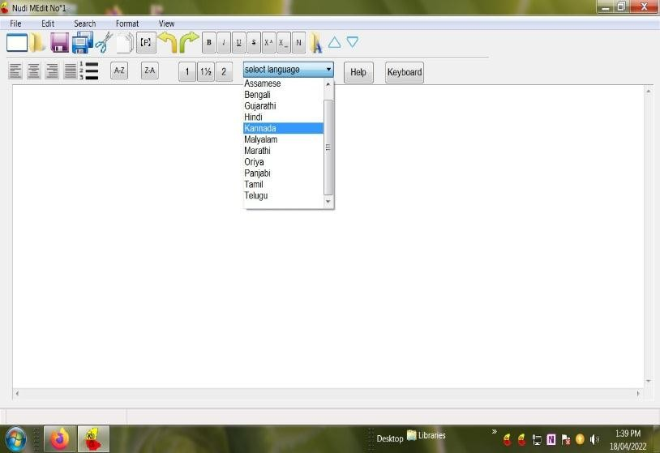4. 5.0

1. 6.0

1. 6.1 same versions
2. 6.5 → It has a 12 languages.
   1. Assam
   2. Bengal
   3. Guajarati
   4. Kannada
   5. Tamil
   6. Telagu
   7. Malayalam
   8. Punjab
   9. Orissa
   10. English
   11. Hindi
   12. Marathi

|  |  |  |  |  |  |  |  |  |  |  |  |  |  |  |  |  |
| --- | --- | --- | --- | --- | --- | --- | --- | --- | --- | --- | --- | --- | --- | --- | --- | --- |
| **ಅ** | | **ಆ** | **ಇ** | **ಈ** | **ಉ** | **ಊ** | **ಋ** | **ೠ** | **ಎ** | **ಏ** | **ಐ** | **ಒ** | **ಓ** | **ಔ** | **ಅಂ** | **ಅಃ** |
| **a** | | **A** | **i** | **I** | **u** | **U** | **R** | **RX** | **e** | **E** | **Y** | **o** | **O** | **V** | **aM** | **aH** |
| **ಕ** | | **ಕಾ** | **ಕಿ** | **ಕಿೀ** | **ಕು** | **ಕೂ** | **ಕೃ** | **ಕೄ** | **ಕೆ** | **ಕೆೀ** | **ಕೆೈ** | **ಕೊ** | **ಕೊೀ** | **ಕೌ** | **ಕಂ** | **ಕಃ** |
| **K** | | **kA** | **ki** | **kI** | **ku** | **kU** | **kR** | **kRX** | **ke** | **kE** | **kY** | **ko** | **kO** | **kV** | **kM** | **kh** |
| **ಖ** | | **ಖಾ** | **ಖಿ** | **ಖಿೀ** | **ಖು** | **ಖೂ** | **ಖೃ** | **ಖೄ** | **ಖೆ** | **ಖೆೀ** | **ಖೆೈ** | **ಖೊ** | **ಖೊೀ** | **ಖೌ** | **ಕಂ** | **ಕಃ** |
| **K** | | **KA** | **Ki** | **KI** | **Ku** | **KU** | **KR** | **KRX** | **Ke** | **KE** | **KY** | **Ko** | **KO** | **KV** | **KM** | **KH** |
| **ನ್ನ** | | **ಣ್ಣ** | **ದ್ದ** | **ವ್ವ** | **ಸ್ಸ** | **ಕಕ** | **ತ್ತ** | **ಪ್ಪ** | **ಕಸ** | **ಗ್ನ** | **ತ್ರ** | **ದ್ರ** | **ಪ್ತ** | **ಗ್ರ** | **ಬ್ರ** | **ಸ್ರ** |
| **nfn** | | **NfN** | **dfd** | **vfv** | **sfs** | **kfk** | **tft** | **pfp** | **kfs** | **gfn** | **tfr** | **dfr** | **pft** | **gfr** | **bfr** | **Sfr** |
| **rfy** | **yF** | **sMKfye** | **Ssftfr** | **DYrfy** | **nirfBy** | **AvixfkAr** | **nirfmAN** | **spfrEm** | **Dnfy** | **hubfbLfLi** | **rAjfy** | **rtfn** | **sVKfy** | **SfrI** | **sftfrI** | **rAxfqfr** |
| **ರ್ಯ** | **ರ್ಯ** | **ಸಂಖ್ಯೆ** | **ಶಸ್ತ್ರ** | **ಧೆೈರ್ಯ** | **ನಿರ್ಭಯ** | **ಆವಿಷ್ಕಾರ** | **ನಿರ್ಮಾಣ** | **ಸಪ್ರೇಮ** | **ಧನ್ಯ** | **ಹುಬ್ಬಳ್ಳಿ** | **ರಾಜ್ಯ** | **ರತ್ನ** | **ಸೌಖ್ಯ** | **ಶ್ರೀ** | **ಸ್ತ್ರೀ** | **ರಾಷ್ಟ್ರ** |

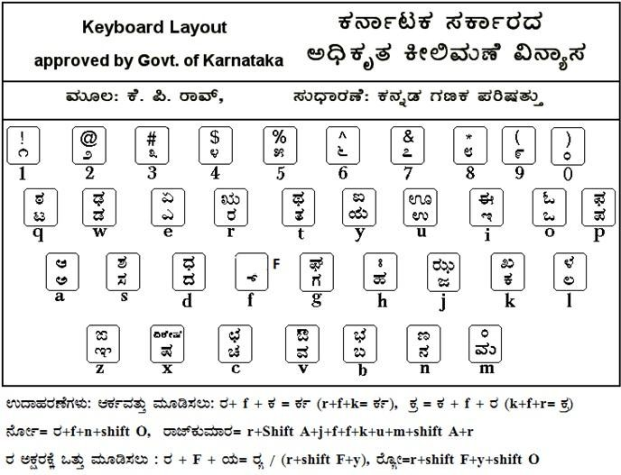

Note : Caps lock Off (ಕೆಳಗೆ ಇರುವ ಚೌಕದಲ್ಲಿನ ಎಲ್ಲಾ ಮೇಲಿನ ಅಕ್ಷರಗಳಿಗೆ Shift key ಅನ್ನು ಉಪಯೋಗಿಸಿ)

|  |  |  |  |  |  |
| --- | --- | --- | --- | --- | --- |
| **ಕ** | **ಖ** | **ಗ** | **ಘ** | **ಙ** | |
| **k** | **K** | **g** | **G** | **Z** | |
| **ಚ** | **ಛ** | **ಜ** | **ಝ** | **ಞ** | |
| **c** | **C** | **j** | **J** | **z** | |
| **ಟ** | **ಠ** | **ಡ** | **ಢ** | **ಣ** | |
| **q** | **Q** | **w** | **W** | **N** | |
| **ತ** | **ಥ** | **ದ** | **ಧ** | **ನ** | |
| **t** | **T** | **d** | **D** | **n** | |
| **ಪ** | **ಫ** | **ಬ** | **ಭ** | **ಮ** | |
| **p** | **P** | **b** | **B** | **m** | |
| **ಯ** | **ರ** | **ಲ** | **ವ** | **ಶ** | |
| **y** | **r** | **l** | **v** | **S** | |
| **ಷ** | **ಸ** | **ಹ** | **ಳ** | **ಕ್ಷ** | **ಜ್ಞ** |
| **x** | **s** | **h** | **L** | **kfx** | **jfz** |

ಬೆರೆ ಯಾವುದೇ ಅಪ್ಲಿಕೆಷನ್‌ಗಳಲ್ಲಿ ನುಡಿ ಬಳಸಬೇಕಾದರೆ ನೇರ ನುಡಿ (Nudi Direct) ಗೆ ಬದಲಾಯಿಸಬೇಕು

ಉದಾಹರಣೆಗೆ : MS Word ನಲ್ಲಿ ಈ ಕೆಳಗಿನ Assignment ಮಾಡಿ

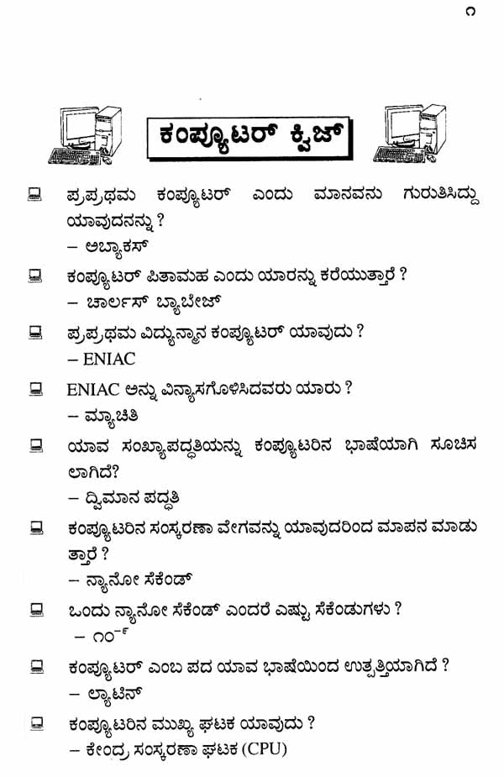

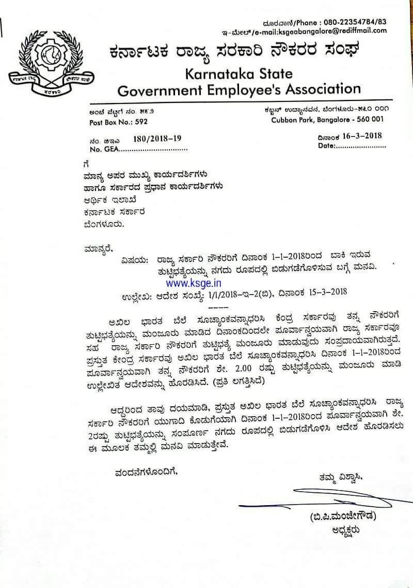

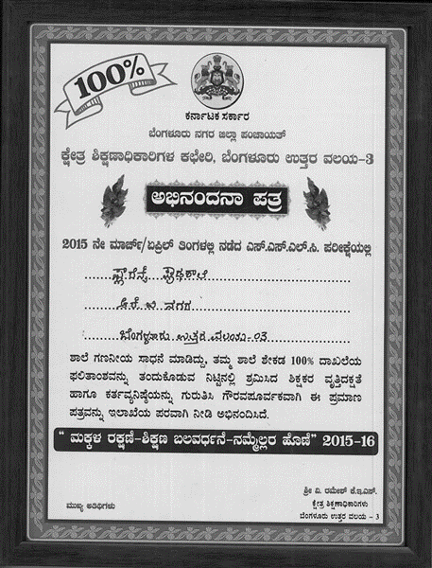

**5**

## Microsoft Excel

Microsoft Excel is a commercial spreadsheet application, written and distributed by Microsoft for Microsoft Windows and Mac OS X. At the time of writing this tutorial the Microsoft excel version was 2010 for Microsoft Windows and 2011 for Mac OS X.

Microsoft Excel is a spreadsheet tool capable of performing calculations, analyzing data and integrating information From different programs. By default, documents saved in Excel 2010 are saved with the .xlsx extension whereas the file extension of the prior Excel versions are .xls. The following basic window appears when you start the excel application. Let us now understand the various important parts of this window.

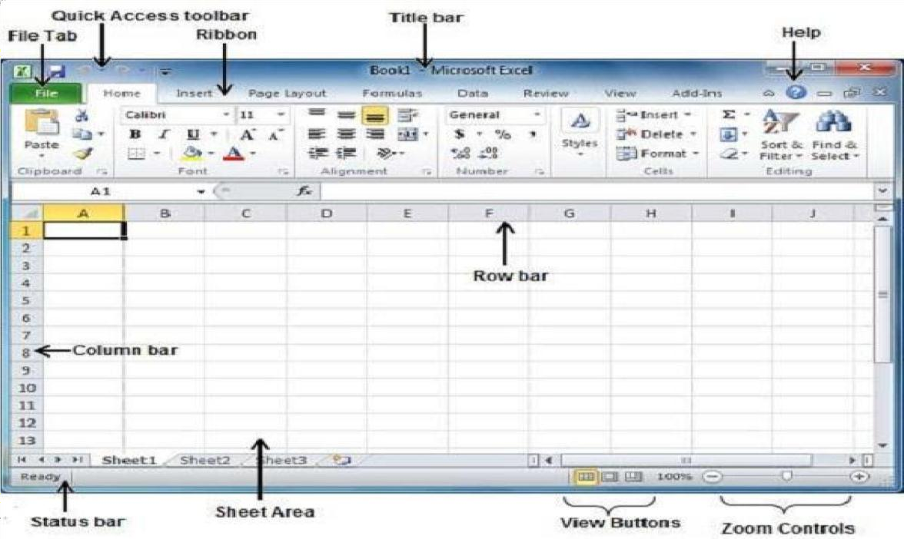

**File Tab**

The File tab replaces the Office button from Excel 2007. You can click it to check the **backstage view,** where you come when you need to open or save files, create new sheets, print a sheet, and do other file-related operations. Quick Access Toolbar

You will find this toolbar just above the **File tab** and its purpose is to provide a convenient resting place for the Excel's most frequently used commands. You can customize this toolbar based on your comfort.

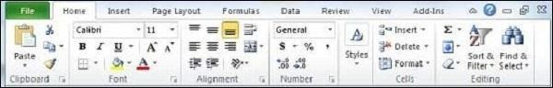**Ribbon**

Ribbon contains commands organized in three components −

* **Tabs** − they appear across the top of the Ribbon and contain groups of related commands. Home, Insert, Page Layout are the examples of ribbon tabs.
* **Groups** − they organize related commands; each group name appears below the group on the Ribbon. For example, group of commands related to fonts or group of commands related to alignment etc.
* **Commands** − Commands appear within each group as mentioned above.

##### Title Bar

This lies in the middle and at the top of the window. Title bar shows the program and the sheet titles.

##### Help

The **Help Icon** can be used to get excel related help anytime you like. This provides nice tutorial on various subjects related to excel.

##### Zoom Control

Zoom control lets you zoom in for a closer look at your text. The zoom control consists of a slider that you can slide left or right to zoom in or out. The + buttons can be clicked to increase or decrease the zoom factor.

##### View Buttons

The group of three buttons located to the left of the Zoom control, near the bottom of the screen, lets you switch among excels various sheet views.

**Normal Layout view** − this displays the page in normal view.

* + **Page Layout view** − this displays pages exactly as they will appear when printed. This gives a full screen look of the document.
  + **Page Break view** − this shows a preview of where pages will break when printed.

##### Sheet Area

The area where you enter data. The flashing vertical bar is called the **insertion point** and it represents the location where text will appear when you type.

##### Row Bar

Rows are numbered from 1 onwards and Keeps on increasing as you keep entering data. Maximum limit is **10,48,576 rows.**

##### Column Bar

Columns are numbered from A onwards and Keeps on increasing as you Keep entering data. After Z, it will start the series of AA, AB and so on. Maximum limit is **16,384 columns.** **Status Bar**

##### Dialog Box Launcher

This appears as a very small arrow in the lower-right corner of many groups on the Ribbon. Clicking this button opens a dialog box or task pane that provides more options about the group.

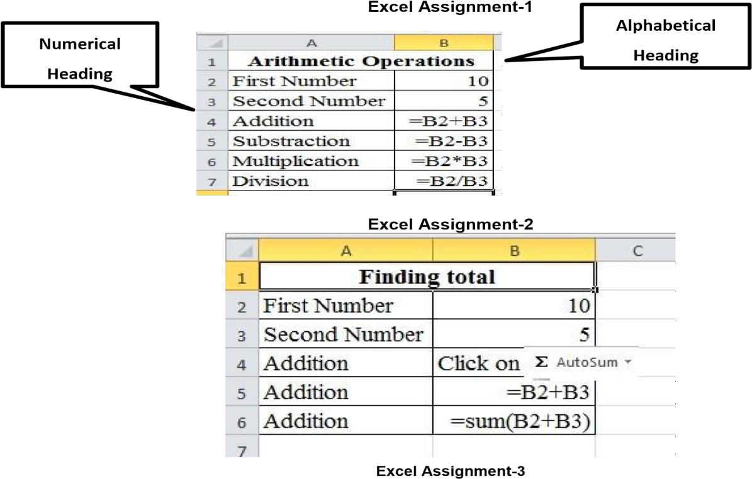



Excel Assignment -3 Excel Assignment -4

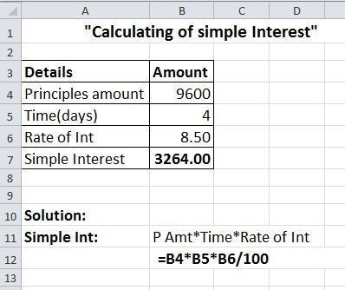

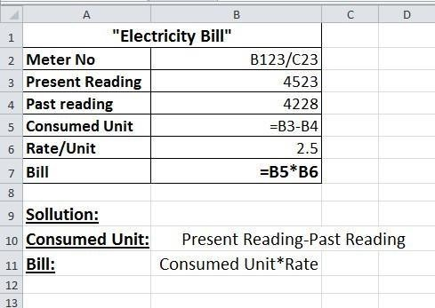

**Excel Assignment-5**

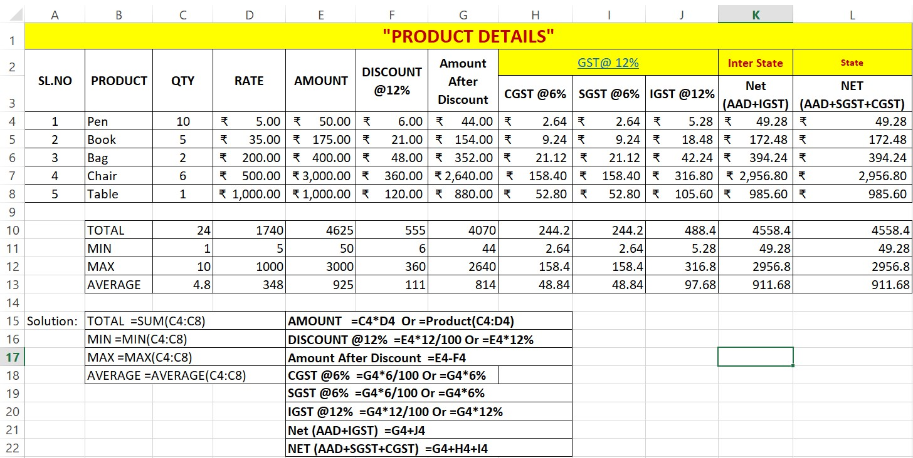

**Excel Assignment-6**

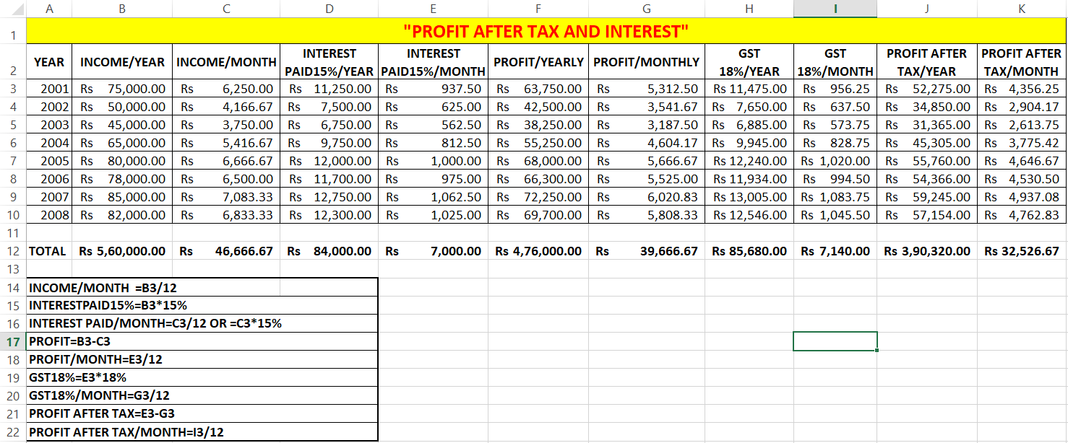

=B3-D3

=C3-E3

/ YEAR =F3*18%

=G3*18%

=F3-H3

=G3-I3

**Excel Assignment-7**

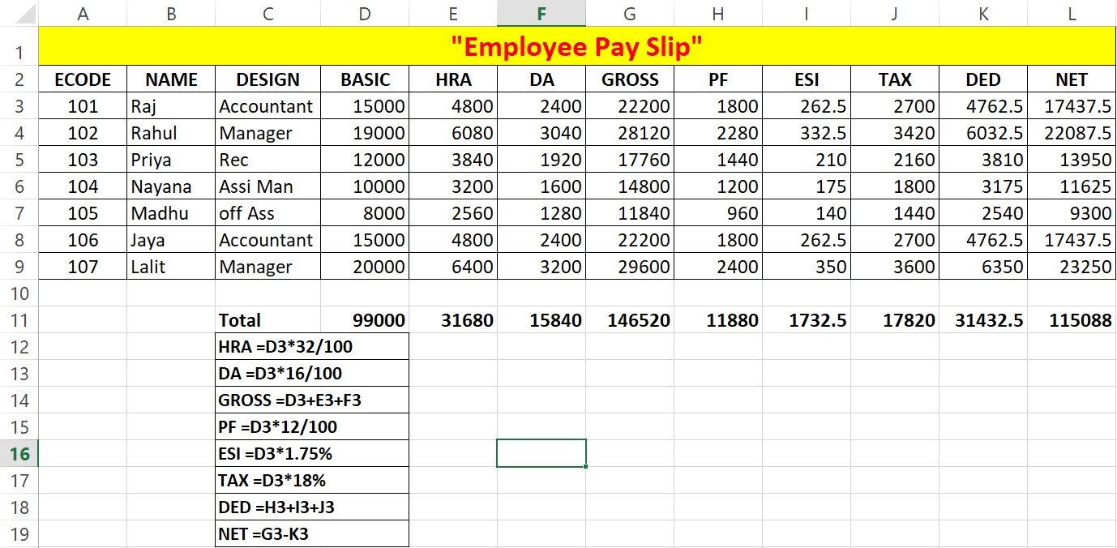

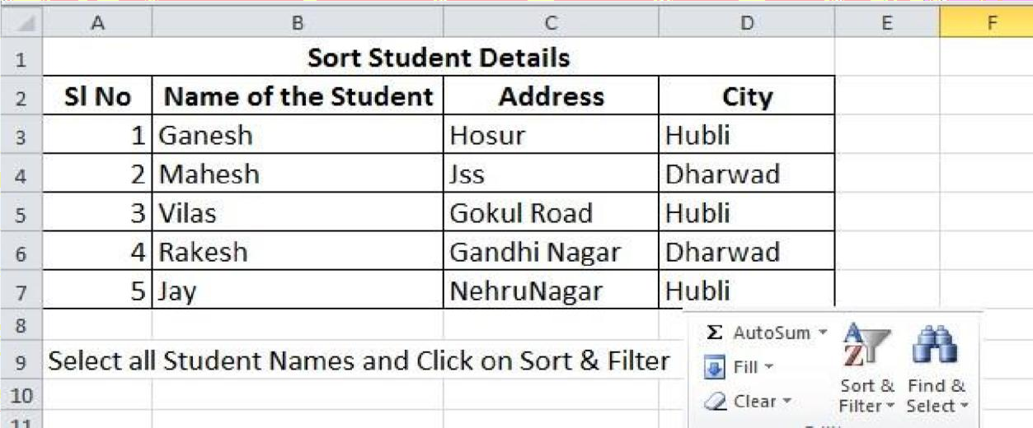**Excel Assignment-8**

# What is an Excel Function?

**A function in Excel is a preset formula that helps perform mathematical, statistical and logical operations. Once you are familiar with the function you want to use, all you have to do is enter an equal sign (=) in the cell, followed by the name of the function and the cell range it applies to.**

# 1)IF Function

**The IF function in Excel performs a logical comparison between two values. The result of the IF function is either TRUE or FALSE. For example, we can test if the value in cell B2 is greater than the value in cell A2. If so, the result is TRUE, if not, the result is FALSE.**

**Excel Assignment-9**

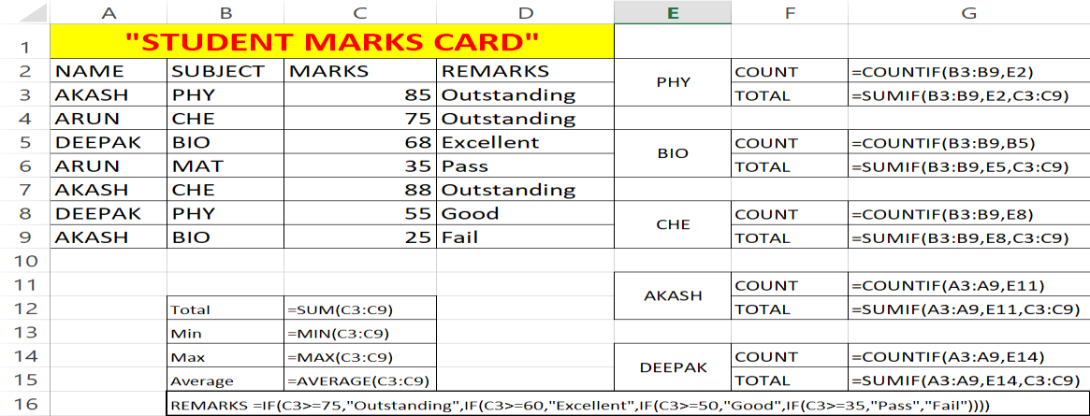

**Excel Assignment-10**

# 

# 

# 2)_Dated IF :

# Calculates the number of days, months, or years between two dates. Warning: Excel provides the DATEDIF function in order to support older workbooks from Lotus 1-2-3. The DATEDIF function may calculate incorrect results under certain scenarios

# Excel Assignment-11

# 2_Logical Function In Excel

* **AND** – =IF(AND(Something is True, Something else is True), Value if True, Value if False)
* **OR** – =IF(OR(Something is True, Something else is True), Value if True, Value if False)
* **NOT** – =IF(NOT(Something is True), Value if True, Value if False)

# Excel Assignment-12

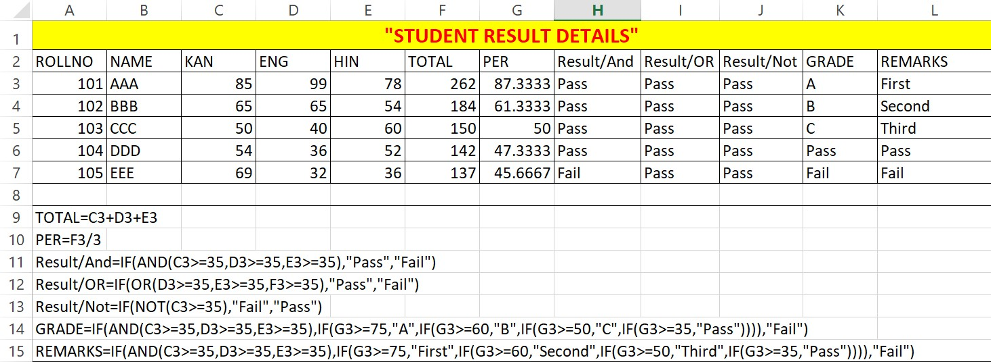

### Formatting Cell

**Insert Columns or Rows:** When you select a row or column that has formatting applied, that formatting will be transferred to a new row or column that you insert. If you don't want the formatting to be applied, you can select the **Insert Options** button after you insert, and choose from one of the options as follows: Short cut Key **Ctrl +**

### Delete a column

1. Select any cell within the column, then go to **Home** > **Insert** > **Insert Sheet Columns**or **Delete Sheet**
2. **Columns**. Or Short Cut Key **Ctrl + -**
3. Alternatively, right-click the top of the column, and then select **Insert** or **Delete**.

### Delete a row

1. Select any cell within the row, then go to **Home** > **Insert** > **Insert Sheet Rows**or **Delete Sheet Rows**.
2. Alternatively, right-click the row number, and then select **Insert** or **Delete**. Or Short cut Key Ctrl + -

**Increase Row Height & Column Width** 1. Select Row or Column to be Increase Height Or Width   
 2. Go to Home Tab --- Cells Group – Choose Option Row Height Or Column width

## Excel Charts

Charts are visual representations of data used to make it more understandable.

**Steps to Insert Chart**  
1) Select your data

2) Go to Insert Tab & Click on chart Icon

OR  
Use **F11 Short cut Key** to insert chart sheet

Commonly used charts are:

* Pie chart
* Column chart
* Line chart

# Excel Assignment-13

##### 

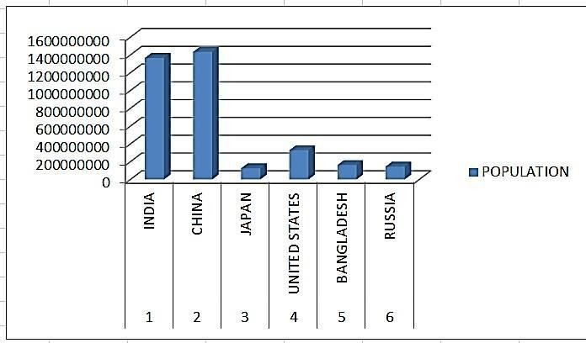

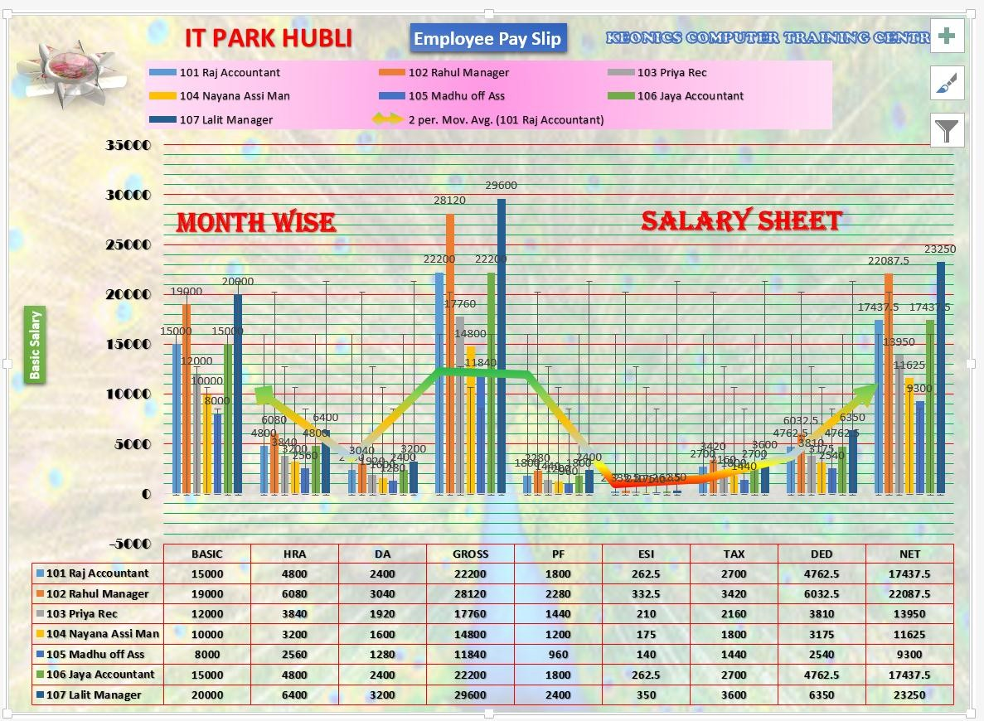

 LOOKUP Function

## The LOOKUP Function is categorized under Excel Lookup and Reference functions. The function performs a rough match lookup either in a one-row or one-column range and returns the corresponding value from another one-row or one-column range. There are mainly 3 Types of Lookup Function

### 1) LOOKUP function

The LOOKUP function in Excel can perform the simplest types of vertical and horizontal lookups.

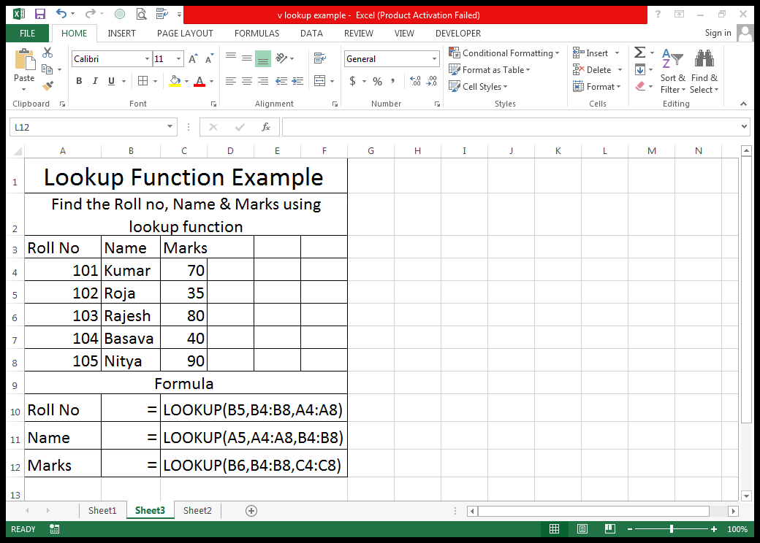

**2) VLOOKUP function**

**Vlookup** is an improved version of the LOOKUP function specially designed to do **vertical lookup** in columns. TRUE – Approximate match - FALSE – Exact match

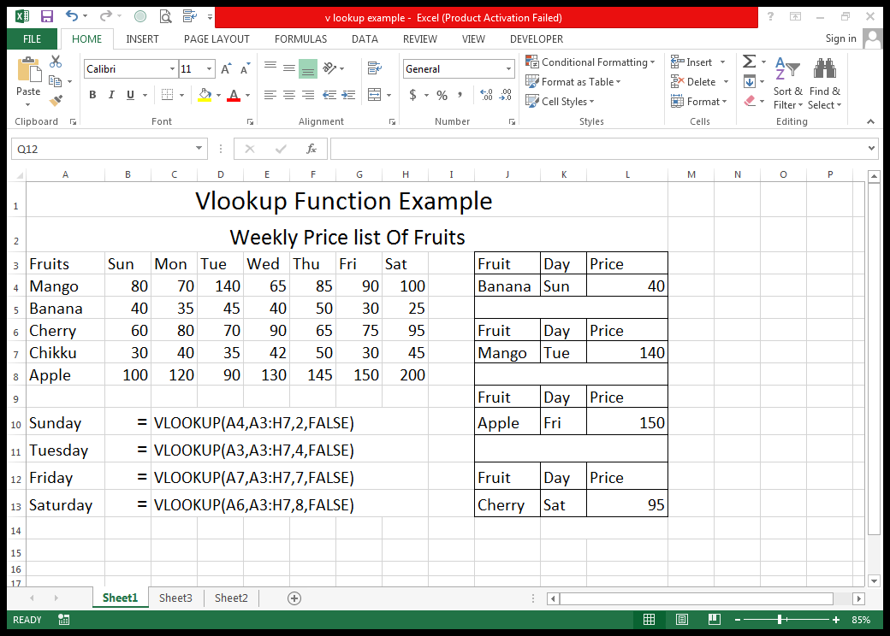

**Price**

**Formula**

### 3) HLOOKUP function

It's a **Horizontal** counterpart of VLOOKUP that searches for a value in the first row of the lookup table and returns the value in the same position from another row.

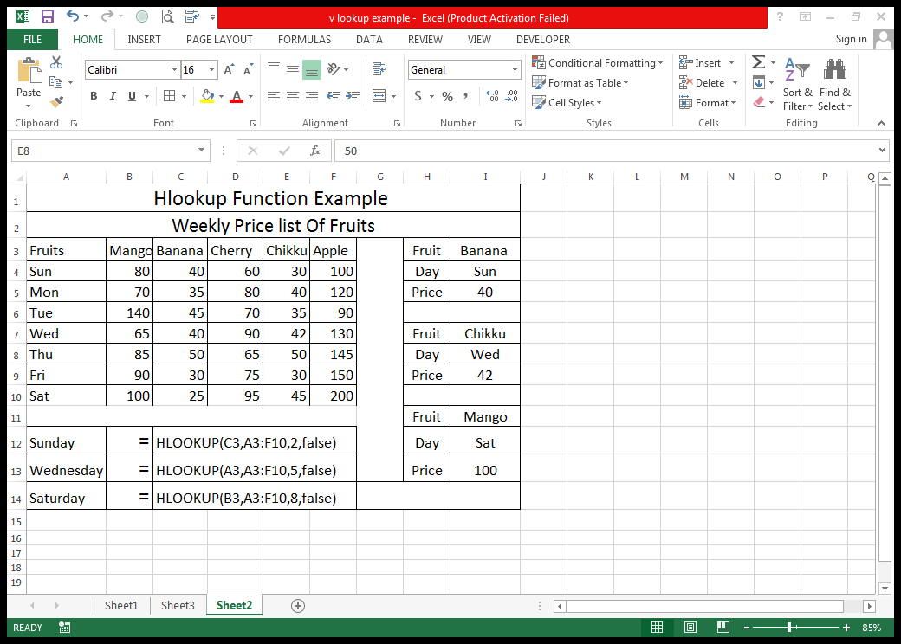

**Price**

**Formula**

**PivotTable & Chart**

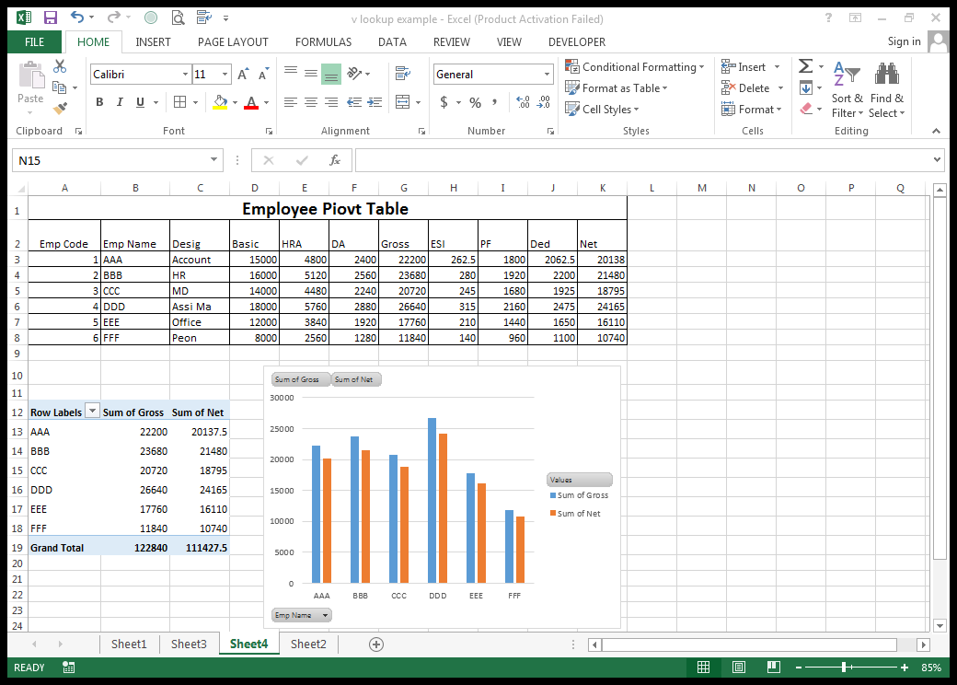A PivotTable is a powerful tool to calculate, summarize, and analyze data that lets you see comparisons, patterns, and trends in your data

**PowerPoint**

MS Power Point is useful in creating presentation, where one can add animation, Photo, Video and Sound Effects making it more readable.

The following screenshot shows the various areas in a standard PowerPoint file. It is important to familiarize yourself with these areas as it makes learning and using PowerPoint easier.

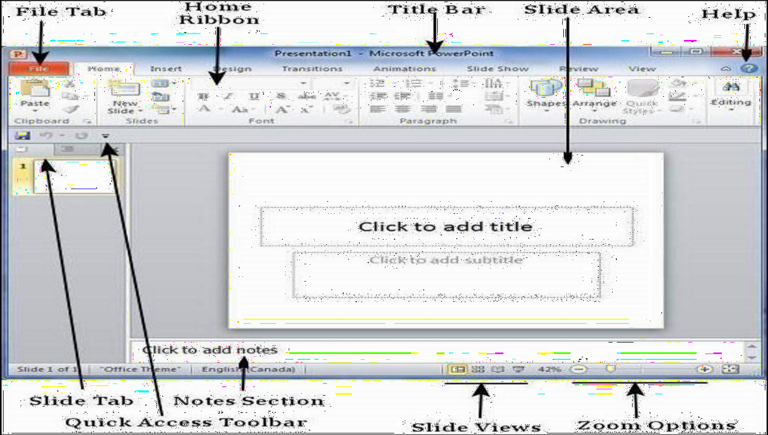

Creating a New Power Point Start all programs MS office Open PowerPoint. Or double-click the PowerPoint app icon, which resembles an orange box with a white "P" on it. This will open the PowerPoint window screen

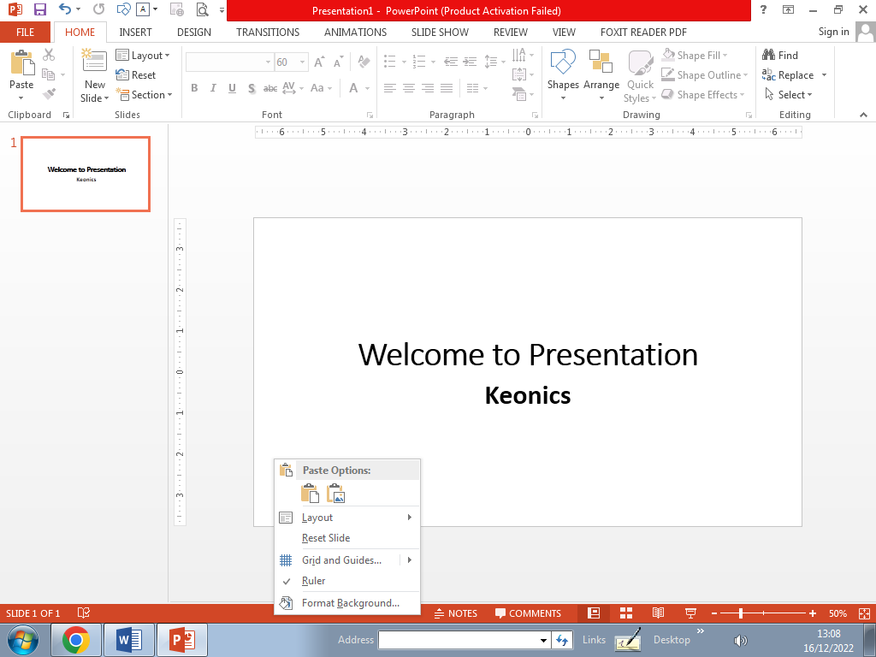

**Start Your Assignment By using different types of Slide Layouts**

To Add Slide layout ---- 1) Got home tab

2) Select Slide layout option to take layouts

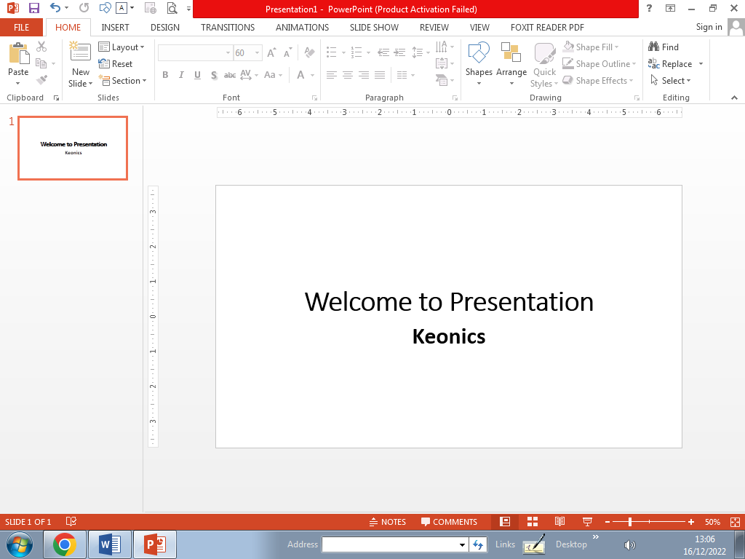  
1) Title Slide 2) Title and Content Slide

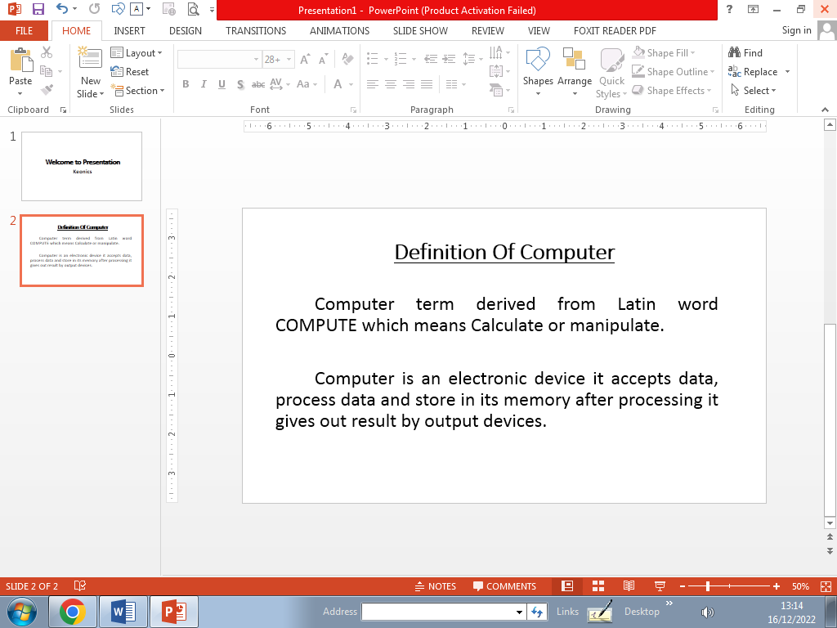

3) Use Blank Slide Layout 4) Comparision Slide Layout

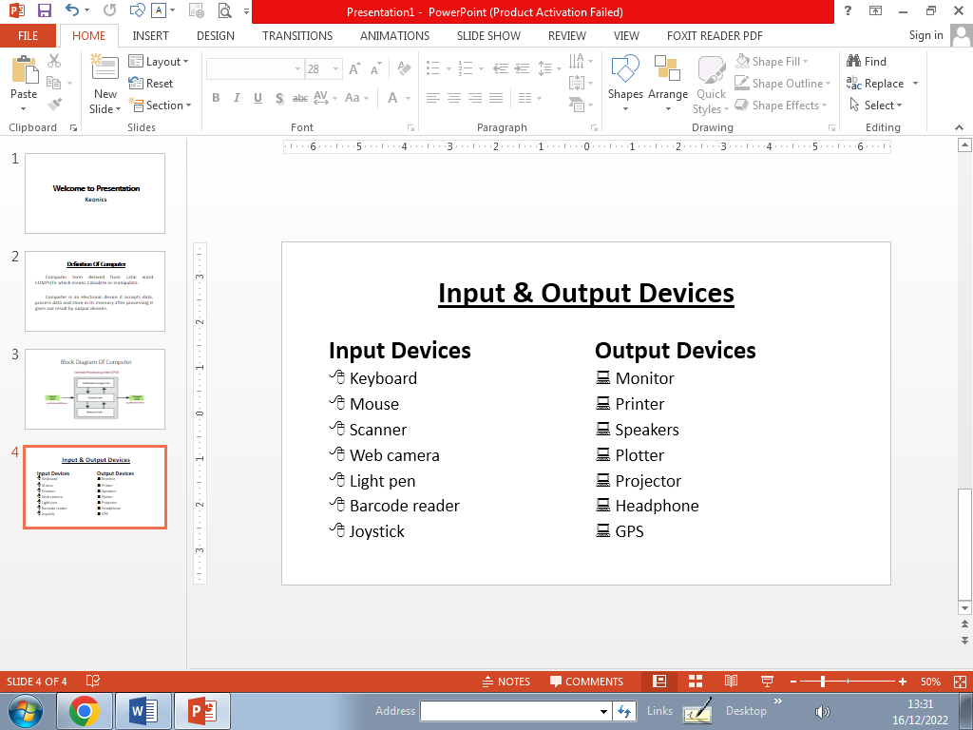

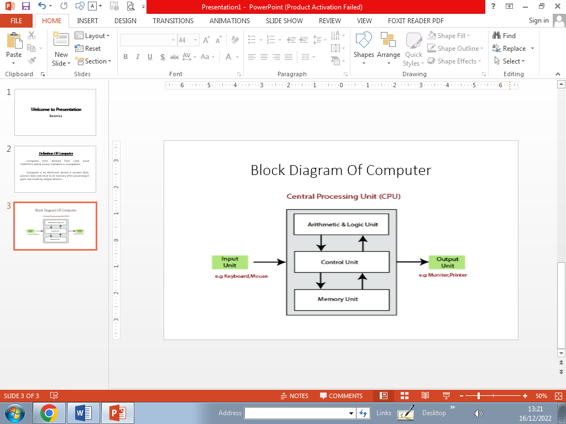

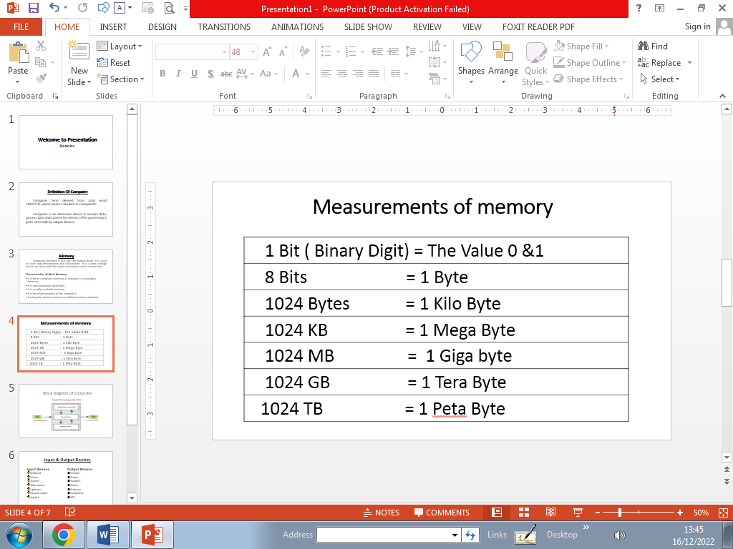5) Title and Content Slide 6) Use Blank Slide Layout

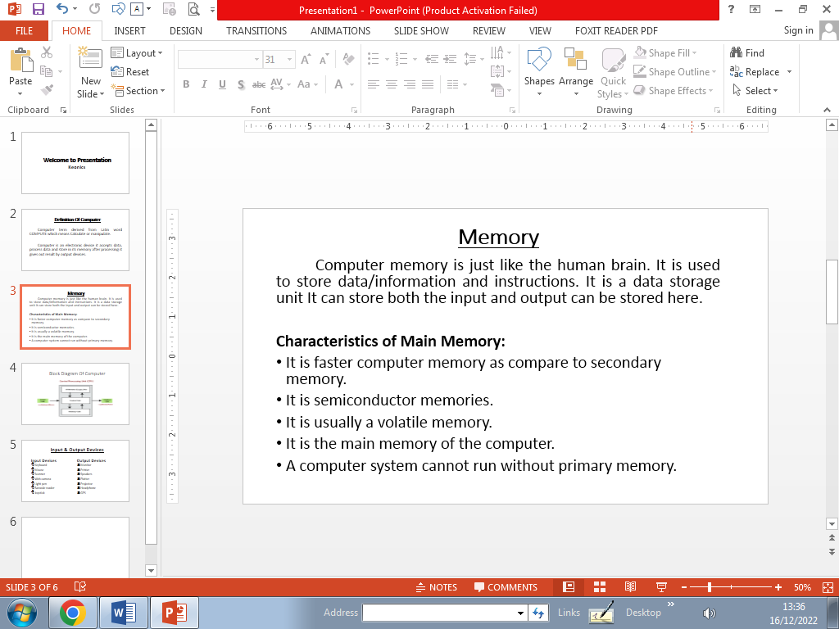

7) Title and Content Slide 8) Take Blank slide loyout & Insert word art   
 insert Video

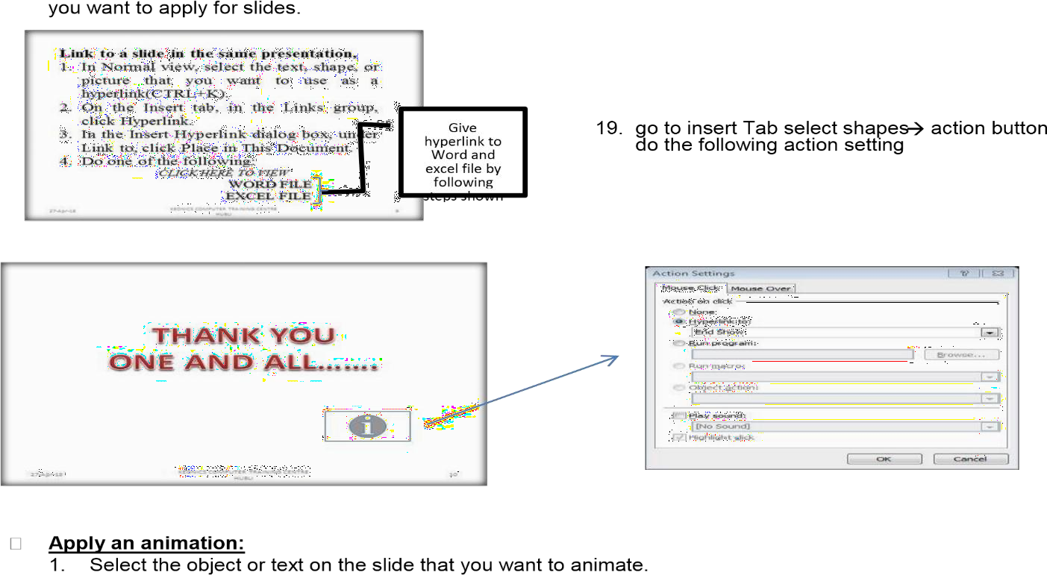

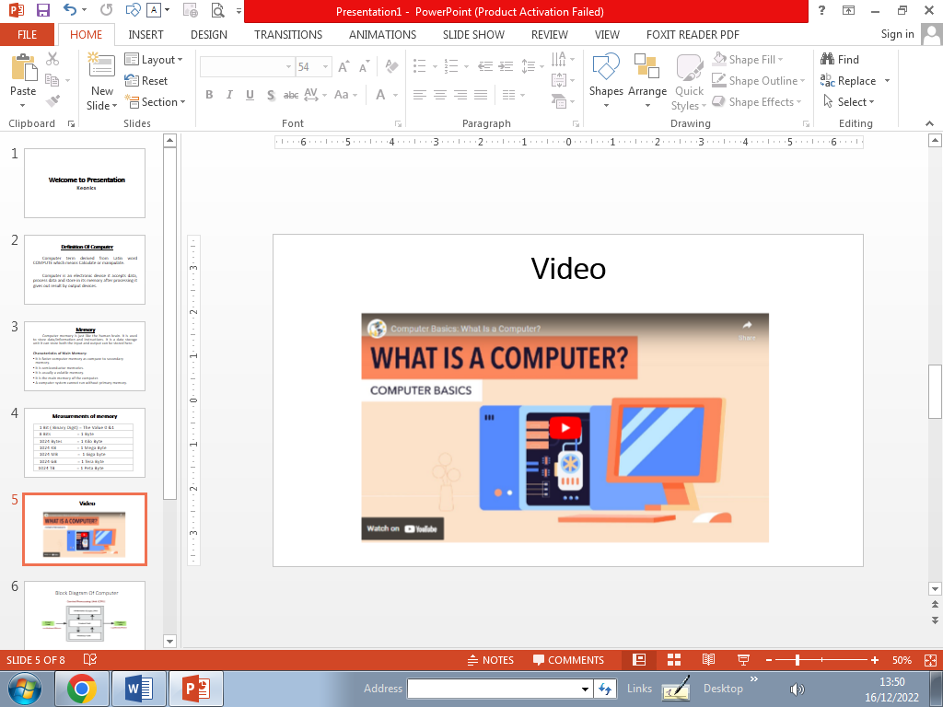

Add Background design to your slide from Design tab

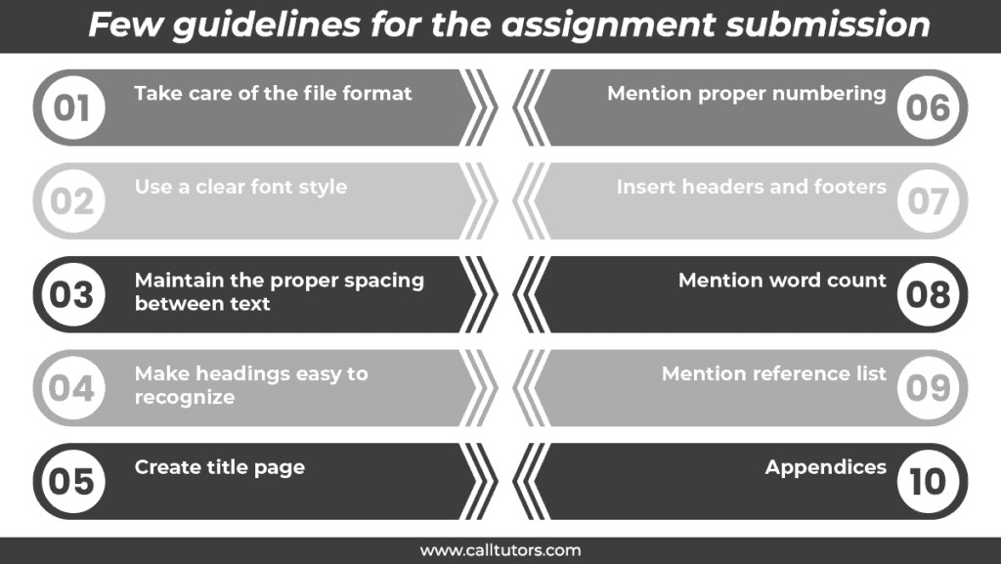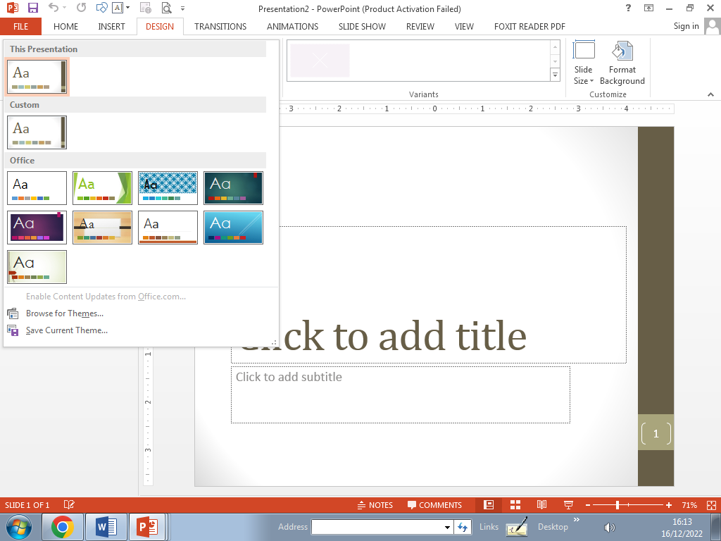

Prepare the following assignment by using shapes & apply custom by giving Appear animation effect to show one after one list

**Creating Photo Album**

To Create Photo Album 1) Go to Insert Tab 2) Select Photo Album 3) Select File/ Disc option from box

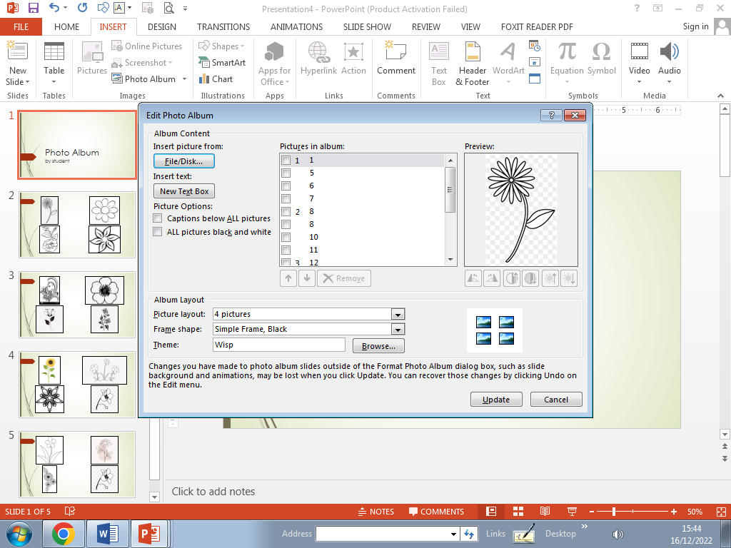

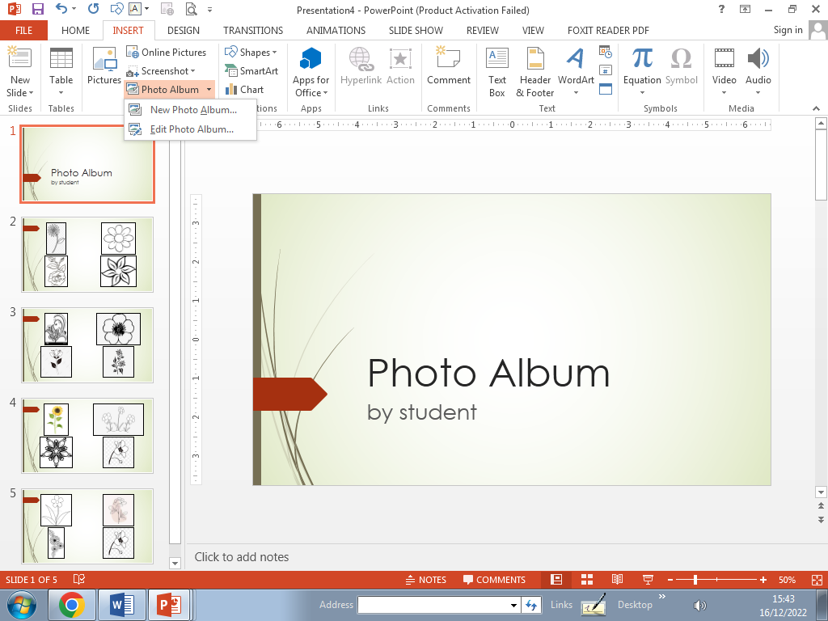

**Transitions**

Transitions are the power point effects between 2 slides

How to add transition effect : - 1) Go to Transition tab

2) Select any one effect to apply each slide

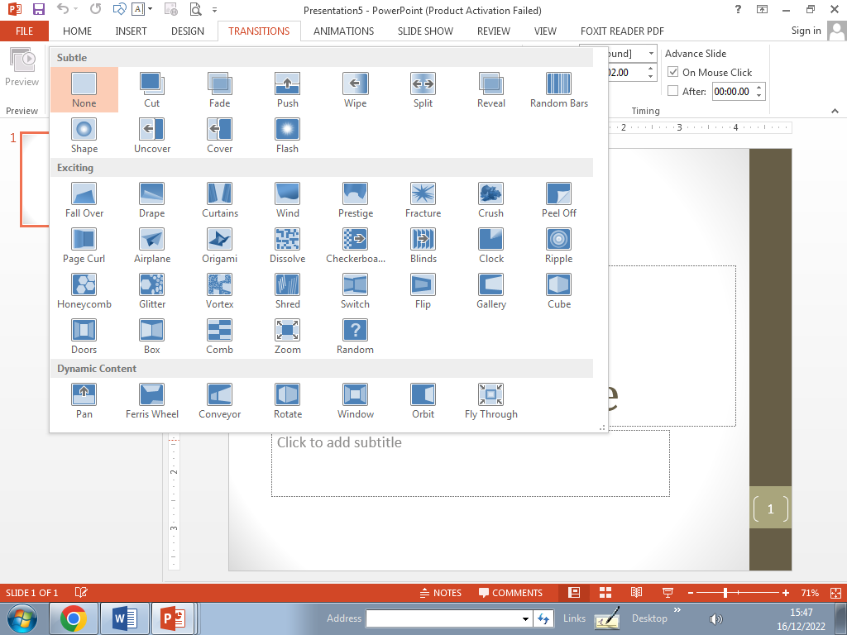

**Custom Animation**

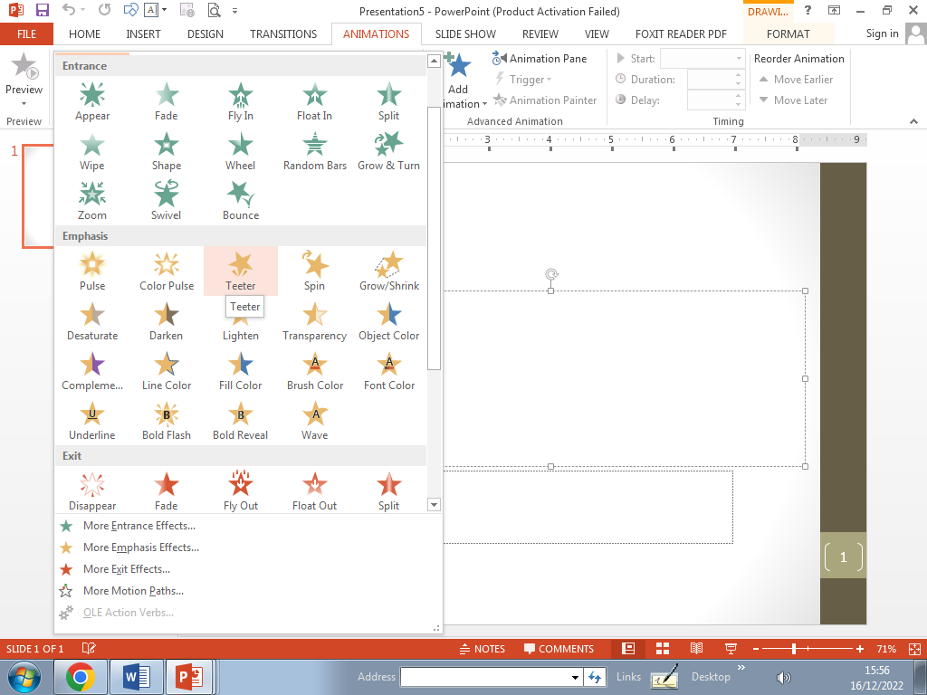Custom animation are the power point effects that we can add to contents and images which we created  
 into the slides.

**INTERNET**

* The internet is a globally connected network system facilitating worldwide communication and access to data resources through a vast collection of private, public, business, academic and government networks.
* The internet **is the world's most popular computer network**.
* In other words Internet is a Network of Network

**Network:**  Two or More computer linked together to share information are called Networking

 **Types of computer network**

1. **Local Area Network (LAN)**

A LAN connects network devices over a relatively short distance.

A networked office building, school, or home usually contains a single LAN, though sometimes one building will contain a few small LANs (perhaps one per room), and occasionally a LAN will span a group of nearby buildings.

1. **Metropolitan area network (MAN)**
   1. A metropolitan area network (MAN) is a large computer network that usually spans a city or a large campus.
   2. A man often acts as a high speed network to allow sharing of regional resources.
   3. A man typically covers an area of between 5Km and 50Km diameter.
   4. A man might be owned and operated by a single organization, but it usually will be used by many individuals and organizations.
2. **Wide area network(WAN)**
   1. WAN covers a large geographic area such as country, continent whole of the world.
   2. A WAN is a geographically-dispersed collection of LANs.
   3. Most WANs (like the internet) are not owned by any one organization but rather exist under collective or distributed ownership and management.

##### Internet Access

1. To gain access to the internet, the user has to register to any internet service provider (ISP).
2. Types of internet connection:
   * Dial-up
   * Integrated service digital network
   * Asymmetric digital subscriber line
   * Wireless internet connections Internet over satellite How **Internet Works?**
   * Because the internet is a global network of computers, each computer connected to the internet must have a unique address. This address is known as an IP Address.

**Uses of Internet**

* Electronic mail. At least 85% of the inhabitants of cyberspace send and receive e-mail. ...
* Research.
* Downloading files.
* Discussion groups. ...
* Interactive games. ...
* Education and self-improvement. ...
* Electronic newspapers and magazines.

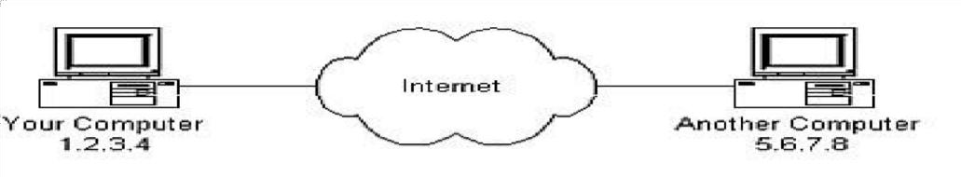

|  |
| --- |
| Internet Requirements  1. Computer with MODEM/Router/Network Card. 2. Internet account with ISP. 3. Application Software: 4. Web Browser(Firefox, Chrome) 5. Email client (MS Outlook) 6. Plugins software(Adobe Reader, Flash Player) 7. Optional: Speaker, Printer, Webcam |

##### World Wide Web:

* + The World Wide Web is a System of interlinked Hypertext document accessed via the internet.
  + With a web browser, one can view web pages that may contain text, images, videos and other multimedia and navigate between them via hyperlinks.
  + It uses a protocol called HTTP-Hypertext Transfer Protocol.
  + HTTP Define how messages are formatted and transmitted, and what actions Web servers and browser should take in response to various commands?
  + A uniform resource locator or URL is the address of a document you will find on the [WWW.](http://WWW/) • The element in a URL:

Protocol://server’s address/filename Example: <http://www.google.com/index.html> **Electronic**

##### Mail (Email)

* + The transmission of messages over communications networks.
  + It is a fast and efficient way to communicate with friends or colleagues.
  + You can communicate with one person at a time or thousands; you can receive and send files and other information.

##### Basic email functions:

🖝 Send and receive mail messages

🖝 Save your messages in a file 🖝 Print mail messages 🖝 Reply to mail messages   
🖝 Attach a file to a mail message

* + - Email address : 🖝**Someone@mail server**
    - The email address has three parts:

🖝 A user name 🖝

An “at” sign (@)

🖝 The address of he user’s mail server

* + - Example [Harris@ftms.edu.my](mailto:Harris@ftms.edu.my) Search Engines
    - A search engine is designed to search for information on the internet.
    - Search Engine presents the search results in the form of a search results list.
    - The search results can be web pages, Images, Videos and other type of files. Examples: o Google o Bing o Yahoo O Info seek

##### E-Commerce

* + - Electronic commerce or E-Commerce consists of the buying and selling of products or services over electronic systems such as the Internet and other computer networks.
    - It includes the entire online process of developing, marketing, selling, delivering, servicing and paying for products and services.
    - Examples: Amazon, flip Kart, Snap deal, Shop clues etc.
      * A **Webpage** is a single page of information on the World Wide Web.
      * **HTML** (Hypertext Markup Language) is used to design webpages.
      * A **Website** refers to a group of web pages identified by a single domain. For example: All of the web pages on the Keonics websites begin with
      * [“ww](http://www.Keonics.in/)w[.Keonics.in](http://www.Keonics.in/)”
      * A **Home page** is the first or a front page of a website. If you were to type [“www](http://www.Keonics.in/).[Keonics.in](http://www.Keonics.in/)” into your web browser, the first web page that came up would be the website’s Home page.
      * A **URL** or “Uniform Resource Locator” is the unique address of each web page. For Example: [“ww](http://www.Keonics.in/)w[.Keonics.in](http://www.Keonics.in/)”
      * **Domain Name:** The domain name consist of two parts. In our example “Keonics.in” is the domain name.
      * Where “Keonics” is the host and “.in” is the top level domain. **Common Top level domains are**

1. .com🖝Commercial or business websites
2. .Gov.🖝 Governments Websites.
3. .mil 🖝 Military websites
4. .org🖝Organization
5. .nic🖝 national informatics Centre
6. .in🖝 India Websites
7. .kar🖝 Karnataka websites

* Email Id Creation steps: - Go to Google Click on email button

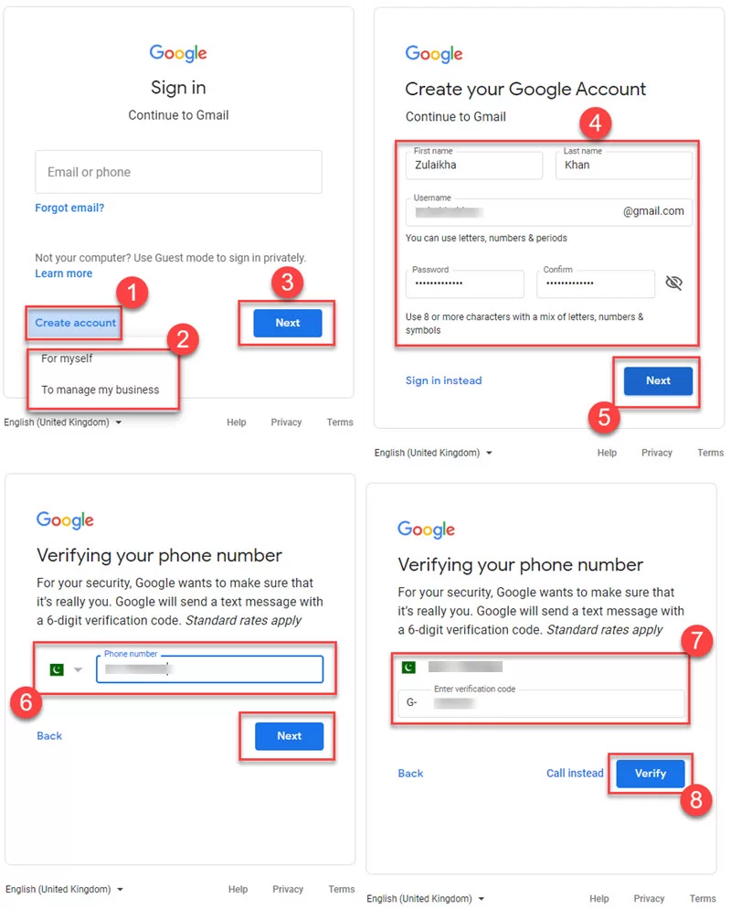

##### Basic PC shortcut Keys

|  |  |
| --- | --- |
| **Shortcut Keys** | **Description** |
| Alt + F | File menu options in current program. |
| Alt + E | Edit options in current program |
| F1 | Universal Help in almost every Windows program. |
| Ctrl + A | Select all text. |
| Ctrl + X | [Cut s](http://www.computerhope.com/jargon/c/cut.htm)elected item. |
| Shift + Del | Cut selected item. |
| Ctrl + C | [Copy s](http://www.computerhope.com/jargon/c/copy.htm)elected item. |
| Ctrl + Ins | Copy selected item |
| Ctrl + V | [Paste](http://www.computerhope.com/jargon/p/paste.htm) |
| Shift + Ins | Paste |
| Home | Goes to beginning of current line. |
| Ctrl + Home | Goes to beginning of document. |
| End | Goes to end of current line. |
| Ctrl + End | Goes to end of document. |
| Shift + Home | Highlights from current position to beginning of line. |
| Shift + End | Highlights from current position to end of line. |
| Ctrl + Left arrow | Moves one word to the left at a time. |
| Ctrl + Right arrow | Moves one word to the right at a time. |

**Microsoft Word shortcut Keys**

|  |  |
| --- | --- |
| **Shortcut Keys** | **Description** |
| Ctrl + 0 | Adds or removes 6pts of spacing before a paragraph. |
| Ctrl + A | Select all contents of the page. |
| Ctrl + B | [Bold hi](http://www.computerhope.com/jargon/b/bold.htm)ghlighted selection. |
| Ctrl + C | [Copy s](http://www.computerhope.com/jargon/c/copy.htm)elected text. |
| Ctrl + E | Aligns the line or selected text to the center of the screen. |
| Ctrl + F | Open find box. |
| Ctrl + I | [Italic hi](http://www.computerhope.com/jargon/i/italic.htm)ghlighted selection. |
| Ctrl + J | Aligns the selected text or line to justify the screen. |
| Ctrl + K | Insert link. |
| Ctrl + L | Aligns the line or selected text to the left of the screen. |
| Ctrl + M | Indent the paragraph. |
| Ctrl + P | Open the print window. |
| Ctrl + R | Aligns the line or selected text to the right of the screen. |
| Ctrl + T | Create a hanging indent. |
| Ctrl + U | Underline highlighted selection. |
| Ctrl + V | [Paste.](http://www.computerhope.com/jargon/p/paste.htm) |
| Ctrl + X | [Cut s](http://www.computerhope.com/jargon/c/cut.htm)elected text. |
| Ctrl + Y | Redo the last action performed. |
| Ctrl + Z | Undo last action. |
| Ctrl + Shift + L | Quickly create [a bullet point.](http://www.computerhope.com/jargon/b/bullet.htm) |
| Ctrl + Shift + F | Change the font. |
| Ctrl + Shift + > | Increase selected font +1pts up to 12pt and then increases font +2pts. |
| Ctrl + ] | Increase selected font +1pts. |
| Ctrl + Shift + < | Decrease selected font -1pts if 12pt or lower, if above 12 decreases font by +2pt. |
| Ctrl + [ | Decrease selected font -1pts. |
| Ctrl + / + c | Insert a cent sign (¢). |
| Ctrl + ' + <char> | Insert a character with an accent (grave) mark, where <char> is the character you want. For example, if you wanted an accented è you would use **Ctrl + ' + e** as your shortcut Key. To  reverse the accent mark use the opposite accent mark, often on th[e tilde Key.](http://www.computerhope.com/jargon/t/tilde.htm) |
| Ctrl + Shift + * | View or hide non printing characters. |
| Ctrl + <left arrow> | Moves one word to the left. |
| Ctrl + <right arrow> | Moves one word to the right. |
| Ctrl + <up arrow> | Moves to the beginning of the line or paragraph. |
| Ctrl + <down arrow> | Moves to the end of the paragraph. |
| Ctrl + Del | Deletes word to right of cursor. |
| Ctrl + Backspace | Deletes word to left of cursor. |
| Ctrl + End | Moves the cursor to the end of the document. |
| Ctrl + Home | Moves the cursor to the beginning of the document. |
| Ctrl + Spacebar | Reset highlighted text to the default font. |
| Ctrl + 1 | Single-space lines. |
| Ctrl + 2 | Double-space lines. |
| Ctrl + 5 | 1.5-line spacing. |
| Ctrl + Alt + 1 | Changes text to heading 1. |
| Ctrl + Alt + 2 | Changes text to heading 2. |
| Ctrl + Alt + 3 | Changes text to heading 3. |
| Alt + Ctrl + F2 | Open new document. |
| Ctrl + F1 | Open th[e Task Pane.](http://www.computerhope.com/jargon/t/taskpane.htm) |
| Ctrl + F2 | Display th[e print preview.](http://www.computerhope.com/jargon/p/prinprev.htm) |
| Ctrl + Shift + > | Increases the highlighted text size by one. |
| Ctrl + Shift + < | Decreases the highlighted text size by one. |
| Ctrl + Shift + F6 | Opens to another open Microsoft Word document. |
| Ctrl + Shift + F12 | Prints the document. |
| F1 | Open Help. |
| F4 | Repeat the last action performed (Word 2000+) |
| F5 | Open the find, replace, and go to window in Microsoft Word. |
| F7 | Spell check and grammar check selected text or document. |
| F12 | Save as. |
| Shift + F3 | Change the text in Microsoft Word from [uppercase](http://www.computerhope.com/jargon/u/uppercas.htm) [to lowercase o](http://www.computerhope.com/jargon/l/lowercas.htm)r a capital letter at the beginning of every word. |
| Shift + F7 | Runs a Thesaurus check on the word highlighted. |
| Shift + F12 | Save. |
| Shift + Enter | Create [a](http://www.computerhope.com/jargon/s/softretu.htm) break [in](http://www.computerhope.com/jargon/s/softretu.htm)stead of a new paragraph. |
| Shift + Insert | Paste. |
| Shift + Alt + D | Insert the current date. |
| Shift + Alt + T | Insert the current time. |

##### Microsoft Excel shortcut Keys

|  |  |
| --- | --- |
| **Shortcut Keys** | **Description** |
| F2 | Edit the selected cell. |
| F5 | Go to a specific cell. For example, C6. |
| F7 | Spell check selected text or document. |
| F11 | Create chart. |
| Ctrl + Shift + ; | Enter the current time. |
| Ctrl + ; | Enter the current date. |
| Alt + Shift + F1 | Insert New Worksheet. |
| Shift + F3 | Open the Excel formula window. |
| Shift + F5 | Bring up search box. |
| Ctrl + A | Select all contents of the worksheet. |
| Ctrl + B | Bold highlighted selection. |
| Ctrl + I | Italic highlighted selection. |
| Ctrl + K | Insert link. |
| Ctrl + U | Underline highlighted selection. |
| Ctrl + 5 | Strikethrough highlighted selection. |
| Ctrl + P | Bring up the print dialog box to begin printing. |
| Ctrl + Z | Undo last action. |
| Ctrl + F9 | Minimize current window. |
| Ctrl + F10 | Maximize currently selected window. |
| Ctrl + F6 | Switch between open workbooks or windows. |
| Ctrl + Page up | Move between Excel work sheets in the same Excel document. |
| Ctrl + Page down | Move between Excel work sheets in the same Excel document. |
| Ctrl + Tab | Move between Two or more open Excel files. |
| Alt + = | Create a formula to sum all of the above cells |
| Ctrl + ' | Insert the value of the above cell into cell currently selected. |
| Ctrl + Shift +! | Format number in comma format. |
| Ctrl + Shift + $ | Format number in currency format. |
| Ctrl + Shift + # | Format number in date format. |
| Ctrl + Shift + % | Format number in percentage format. |
| Ctrl + Shift + ^ | Format number in scientific format. |
| Ctrl + Shift + @ | Format number in time format. |
| Ctrl + Arrow Key | Move to next section of text. |
| Ctrl + Space | Select entire [column.](http://www.computerhope.com/jargon/c/column.htm) |
| Shift + Space | Select entire [row.](http://www.computerhope.com/jargon/r/row.htm) |

**SOME MICROSOFT EXCEL FUNCTIONS**

|  |  |  |
| --- | --- | --- |
| Functions | Syntax | Description |
| DATE | =DATE(year,month,day) | Returns the serial number of a particular date |
| MONTH | =MONTH(serial number) | Converts a serial number to a month |
| NOW | =NOW() | Returns the serial number of the current date and time |
| TIME | =TIME(hour,minute,second) | Returns the serial number of a particular time |
| TODAY | =TODAY() | Returns the serial number of today’s date |
| IS NUMBER | =IS NUMBER(value) | Returns TRUE if the value is a number |
| IS TEXT | =IS TEXT(value) | Returns TRUE if the value is text |
| PRODUCT | =PRODUCT (number1, number 2,) | Multiplies its arguments |
| IS NUMBER | =IS NUMBER(value) | Returns TRUE if the value is a number |
| SUM | =SUM (number1, number2,) | Adds its arguments |

|  |  |  |
| --- | --- | --- |
| SUMIF | =SUMIF(range, criteria,[sum_ range]) | Adds the cells specified by a given criteria |
| SUMIFS | =SUMIF (sum_range, criteria_range,criteria) | Adds the cells in a range that meet multiple criteria |
| AVERAGE | =AVERAGE (number1, number 2…) | Returns the average of its arguments |
| COUNT | =COUNT (value1, value2…) | Counts how many numbers are in the list of arguments |
| COUNTA | =COUNTA (value1,value2,) | Counts how many values are in the list of arguments |
| COUNTIFS | =COUNTIFS (criteria_range,cr,  criteria,) | Counts the number of cells within a range that meet multiple  criteria |
| MAX | =MAX (number1, number2…) | Returns the maximum value in a list of arguments |
| MIN | =MIN (number1, number2…) | Returns the minimum value in a list of arguments |
| CONCATENATE | =CONCATENATE (text1, text2…) | Joins several text items into one text item. Easier to use „&‟  instead of the function usually. |
| EXACT | =EXACT(text1,text2) | ChecKs to see if two text values are identical |
| LEN | =LEN(text) | Returns the number of characters in a text string |
| LOWER | =LOWER(text) | Converts text to lowercase |
| TRIM | =TRIM(text) | Removes spaces from text |
| UPPER | =UPPER(text) | Converts text to uppercase |
| CEILING | =CEILING(number, significance) | Rounds a number to the nearest integer or to the nearest  multiple of significance |
| EVEN | =EVEN(number) | Rounds a number up to the nearest even integer |
| FACT | =FACT(number) | Returns the factorial of a number |
| FLOOR | =FLOOR(number, significance) | Rounds a number down, toward zero |
| ODD | =ODD(number) | Rounds a number up to the nearest odd integer |
| PI | =PI() | Returns the value of pi |
| POWER | =POWER(number, power) | Returns the result of a number raised to a power |
| SQRT | =SORT(number) | Returns a positive square root |
| SUMSQ | =SUMSQ (number1, number2…) | Returns the sum of the squares of the arguments |

**Office management Q & A.**

1. CD-ROM stands for ?
   1. Compactable read only memory
   2. Compact data read only memory
2. Bytes
3. Kilo bytes
4. Tera bytes
   1. Compactable disk read only memory

##### Compact disk read only memory

1. Cd comes under types of storage device?
   1. Magnetically storage

##### Optical storage

* 1. Data storage
  2. All of the above

1. The o and 1 in the binary numbering system are called binary digits or ?

##### Bits

1. Pointing device ?
   1. Joy stick
   2. Mouse
   3. Track ball

##### All of the above

1. Characteristic of computer ?
   1. Iq power
   2. Decision making

##### Speed

* 1. None

1. To select multiple files hold_________button?
   1. Shift
   2. Alt + shift

##### Control

* 1. Control + shift

1. An example of an operating system is_______?
   1. Windows xp
   2. Unix or Linux
   3. Mac Os
   4. **All of the above**
2. Date and time are available in desktop __corner?

##### Right

* 1. Left
  2. Top
  3. Bottom

1. A file is a computerized ?
   1. **Path**

##### Record

* 1. Drive
  2. Folder

1. is an operating system?

##### MS windows

* 1. Word
  2. Tally
  3. None of the above

1. What are the uses of internet?
   1. Communication
   2. Information retrieval
   3. Presentation of information

##### All of the above

1. In www .Keonics.com www refer________?
   1. Worldwide window
   2. Word wide window

##### World wide web

* 1. Worldwide window

1. Http stands for ?
   1. Hypertext markup language
   2. Hypertext transfer para
   3. Home text transfer protocol

##### Hypertext transfer protocol

1. E mail is Kind of facility related to_______?
   1. Education
   2. Advertisement
   3. Commerce

##### Communication

1. IP stands for ?
   1. Internet provider

##### Internet protocol

* 1. Internet procedure
  2. Internet policy

1. To select a block of ext. ClicK at the beginning of the selection. Scroll to end of the selection, position the mouse pointer at the end of the selection, hold down the Key, and then clicK (or drag through the text).
   1. Ctrl
   2. Alt

##### Shift

* 1. Tab

1. In MS word short cut Key for replace is______?

##### Ctrl + h

##### Ctrl + f

##### Ctrl + a

##### Ctrl + u

1. The word count command on the tools menu displays the number of words as well as the number of in the current document.
   1. Lines
   2. Characters
   3. Paragraphs

##### All of the above

1. In MS word headers and footers appear only_____?
   1. Normal view
   2. Web layout
   3. Outline view

##### Print layout view

1. Which can be used for quick access to commonly used commands and tools?
   1. Status bar

##### Tool bar

* 1. Menu bar
  2. Title bar

1. The feature of word that automatically adjusts the amount of space between certain combinations of characters so that an entire word looks more evenly spaced. What is that feature called?

##### Spacing

* 1. Scaling
  2. **Kerning**
  3. Positioning

1. In ms word short cut Key to align justify is________?
   1. Shift + j

##### Ctrl + j

* 1. Alt + j
  2. Shift + ctrl + j

1. A is a collection of predefined design elements and color schemes.
   1. Feature
   2. Hyperlink
   3. Palette

##### Theme

1. A bookmark is an item or location in document that you identify as a name for future reference. Which of the following task is accomplished by using bookmarks?
   1. To add anchors in web page
   2. To mark the ending of a paragraph of document

##### To quickly jump to specific location in document

* 1. To add hyperlinks in webpage

1. Which of the following helps to reduce spelling error in the document?
   1. Auto format

##### Auto correct

* 1. Smart tags
  2. Auto text

1. If you want to you the text in a1 to g1 range cells, option used is ?

##### Merge cells

* 1. More cells
  2. Insert cells
  3. All cells

1. Which of the following function will use to find the highest number in a series of number in excel?

##### Max(b1:b3)

* 1. Maximum(b1:b3)
  2. High(b1:b3)
  3. Highest(b1:b3)

1. What is the quickest way to select entire worksheet in excel?
   1. Choose edit -> select all from the menu
   2. ClicK on the first column, press ctrl and then clicK on the last column.
   3. ClicK on the first column, press shift  
      and then clicK on the last column
2. is the extension name for PowerPoint
   1. .doc
   2. .xls
   3. .bmp

##### None of the above

1. Which of the following should you use if you want all the slides in the presentation to have the same’ look’?
   1. The slide layout option
   2. Add a slide option
   3. Outline view

##### A presentation design template

1. Shortcut Key to slide from current slide is_______?

?

##### ClicK on the rectangle box on the upper left corner where column and row headings meet.

1. Which is not a data source component?

##### Mail merge

* 1. Header row
  2. Data fields
  3. Data records

1. If you want to record experiment information and create a chart that shows the rate of crystal growth over a period of time the best application to use would be

?

* 1. Word processing

##### Spreadsheet

* 1. Database
  2. Graphics

1. Which of the following is correct in excel?

a. =power(2^3)

##### b. =power(2,3)

c. =power(2#3)

d. =power(2*3)

1. What should be add before a fraction to avoid entering it as a date?
   1. //
   2. Fr
   3. Zero

##### Zero space

1. Selecting the rows 5 & 6 then choose→row what will happen in excel?

##### 2 rows will be inserted after row 4

* 1. 2 rows will be inserted after row 5
  2. 2 rows will be inserted after row 6
  3. 2 rows will be inserted after row 7

1. How to remove the unwanted action from recorded macro without recording the whole macro again in excel?
   1. By using the find and edit action option
   2. By clicking on the refresh button in the macro toolbar

##### By edit the macro in the visual basic editor

* 1. Macro cannot be edited

1. In order to arrange the countries from those with the highest population to those with the lowest. You need to sort on the population field in ?
   1. Ascending order

##### Descending order

* 1. Alphabetical order
  2. Random order

1. F9
2. F6
3. F3

##### F5

1. shortcut Key is used for slide show

##### F5

* 1. F3
  2. F1
  3. None of the above

1. Which of the following section does not exist in a slide layout?
   1. Titles
   2. Lists
   3. Charts

##### Animations

1. Nudi can be used for dynamic font embedding purposes
   1. False

##### True

* 1. A & b
  2. None

1. We can type file name in Kannada using_______?
   1. Ekbhashe

##### Unicode

* 1. Dwibhashe
  2. Nudi 01 e

1. Ksclp stand for
   1. Script code for language processing
   2. Karnataka script code for language processing

##### Kannada script code for language processing

* 1. None

1. Nudi is a

##### Application software

* 1. System software
  2. Utility software
  3. Driver

1. Web enabled font in Nudi is?
   1. Nudi 01-e

##### Nudi b akshara(Unicode)

* 1. Nudi sarala
  2. Nudi – web

1. A web site’s front page/main page is called_______?
   1. Browser page
   2. Search page

##### Home page

* 1. Bookmark

1. Moving from one website to another is called?
   1. Downloading

##### Browsing

* 1. Uploading
  2. Attachment

1. Usb stands for ?

##### Universal serial bus.

* 1. Universal series bus
  2. Universal switch band
  3. All the above

1. ISP stands for ?

##### Internet service provider

* 1. Internet service publisher
  2. Internet server provider
  3. All the above

1. A computer on internet are identified by:
   1. E-mail address
   2. Street address

##### Ip address

* 1. None of the above

1. Number of user interfaces are there?
   1. 4

##### 2

* 1. 3
  2. 1

1. The two Kinds of main memory are______?
   1. Primary and secondary
   2. Random and sequential

##### Rom and ram

* 1. All of above

1. is responsible for at calculations and logical operations that have to be performed on the data?
   1. Control unit

##### Arithmetic and logic unit

* 1. Central processing unit
  2. None of the above

1. Which is the device that converts computer output into a form that can be transmitted over a telephone line?
   1. Switch

##### Modem

##### Scanner

##### Monitor

1. A bar contacting a scale that indicates, paragraph indents and margins is

?

##### The ruler

* 1. The ribbon
  2. The menu bar
  3. None of the above

1. Short cut Key to close a files is ?

##### Alt + f4

* 1. Ctrl + f4
  2. F1
  3. F5

1. Internet is a ?
   1. Software programmer
   2. Operating system

##### Network of Networks

* 1. None of above

1. Expansion of www is ?
   1. Wide web word

##### World wide web

* 1. Web wide web
  2. Web world wide

1. In MS word which of the following is not available in font spacing?
   1. Normal

##### Loosely

* 1. Condensed
  2. Expanded

1. “Ctrl + f” is in MS-word?

##### Open find and replace dialog box with activating find tab

* 1. Open page setup dialog box with activating layout tab
  2. Open font dialog box with activating font tab
  3. Open file save as dialog box

1. Which of the following is required before performing mail merge in MS-word?
   1. Create
   2. Modify
   3. Sort

##### All of the above

1. In MS word short cut Key to select all is
2. A binary numbers are represented by

?

##### Digits 0 and 1

* 1. Digits 0, 1,. 8
  2. Digits a,b, c ...
  3. All of the above

1. *.txt is the extension name for ?
   1. Word pad

##### Note pad

* 1. Paint brush

1. Shift +a

##### Ctrl +a

1. Alt +a
2. Shift +Ctrl +a
3. In MS word short cut Key for replace is ?

##### Ctrl +h

* 1. Ctrl +f
  2. Ctrl +a
  3. Ctrl +u

1. To underline the text Keyboard shortcut is

d. None of the above ?

1. Start button will appear in
   1. Desktop
   2. Document

##### Task bar

* 1. My computer

1. Shortcut Key to rename files & folders is

?

* 1. F5
  2. F3
  3. F1

##### F2

1. Alt +u
2. Shift +u
3. Esc +u

##### Ctrl +u

1. In MS word short cut Key of center alignment _?
   1. Ctrl +I
   2. Ctrl +r
   3. Ctrl +K

##### Ctrl +e

1. Which of the following is not available on the ruler of MS word screen?
   1. Tab stop box
   2. Left indent
   3. Right indent

##### Center indent

1. Word art is present in menu in MS-word?
   1. Review
   2. View

##### Insert

* 1. Home

1. In MS word which of the following function Key activates the speller?
   1. F5

##### F7

* 1. F9
  2. Shift +f7

1. Special category of number tab in format cells dialog box can be used to apply formats like

in excel?

* 1. Zip code
  2. Phone number

##### Both of above

* 1. None of above

1. To drag a selected range of data to another worksheet in the same workbook use the

?

* 1. Tab Key
  2. Alt Key
  3. Shift Key

##### Ctrl Key

1. Which of the following is not an option of the spelling dialog box in excel?
   1. Ignore
   2. Ignore all

##### Edit

* 1. Change

1. What is an expression that tells how the numbers in a determined set of cells are to be calculated?

##### Formula

* 1. Field
  2. Data
  3. Query

1. You accidentally erased a record in the sheet, what command can be used to restore it immediately?
   1. Insert
   2. Copy

##### Undo

* 1. Replace

1. is a workbook?

##### Excel

* 1. WordPad
  2. MS-Word
  3. None of the above

1. Formulas in excel start with ?
   1. %

b. =

c. +

d. –

1. Worksheet can be renamed by?
   1. Adding symbol at the end of filename while saving workbook
   2. ClicK on worksheet tab by holding ctrl Key and type new name

##### Double clicK on the worksheet tab and type new name

* 1. Worksheet cannot renamed

1. In excel, a1 refers for ?

##### Cell address

* 1. Cell add
  2. Cell line
  3. Cell border

1. Which of the following is correct in excel? a. =average(4,5,6,7)

b. =average(a1,b1,c1)

c. =average(a1:a9,b1:b9)

##### d. All of the above

1. What happens if you select first and second slide and then clicK on new slide button on toolbar?
   1. A new slide is inserted as first slide in presentation
   2. A new slide is inserted as second slide in presentation

##### A new slide is inserted as third slide in presentation

* 1. None of above

1. _ animation effect present in PowerPoint

##### Windows

* 1. Dos
  2. Web
  3. Linux

1. To insert a hyperlink in a slide ?
   1. Choose insert >> hyperlink
   2. Press ctrl +K
   3. Hyperlinks can’t be inserted in slides

##### Both a & b

1. If you have a PowerPoint show you created and want to send using email to another teacher you can add the show to your email message as a ?
   1. Inclusion

##### Attachment

* 1. Reply
  2. Forward

1. What term describes a background that appears as a grainy, Non-smooth surface?

##### Gradient

* 1. Pattern
  2. Sold
  3. Texture

1. Nudi can be used for dynamic font embedding purposes?
   1. False

##### True

* 1. A&B
  2. None

1. If you do not see Kannada after running Nudi, what will you change to make it visible?
   1. Application
   2. Nudi
   3. User

##### Font

1. Starting Nudi 4.0 program?

##### Start button - all programs – choose nknudi 4.0.

* 1. Choose Nudi 4.0 in MS-office tab
  2. Start button – all programs – choose MS-word.
  3. None

1. Ksclp stands for?
   1. Script code for language processing
   2. Karnataka script code for language processing

##### Kannada script code for language processing

* 1. None

1. Html is used to create ?
   1. Machine language program
   2. High level program

##### Web page

* 1. Web server

1. Which one of the following is not a search engine?
   1. Bing
   2. Google
   3. Yahoo

##### Windows

1. Www. Keonics. In where .in refers?

##### Domain name

* 1. Organization
  2. Both a & b
  3. None of the above

1. The process of transferring files from a computer on the internet to your computer is called ?
   1. Uploading
   2. Forwarding
   3. Ftp

##### downloading

1. Verification of a login name and password is known as?
   1. Configuration
   2. Accessibility

##### Authentication

* 1. Logging in

##### Both a & b

1. None of the above 103.Dde stands for ?
2. Data defection estimation

##### Dynamic data exchanger

1. Both a & b
2. None of the above
3. Note pad is used to create ?
   1. Documents

##### Text files

* 1. Picture files
  2. All the above

1. Icons defined in types
   1. 1
   2. 4

##### 2

* 1. 3

1. Which of the following is not an example of web browser?
   1. Internet explorer
   2. Google chrome
   3. Mozilla Firefox

##### Windows explorer

1. Which of the following is not a font style?
   1. Bold
   2. Italic
   3. Regular

##### Superscript

1. Which of the following commands should you always use before submitting a document to others?
   1. Find command
   2. Replace command

##### Spelling and grammar

* 1. Thesaurus

1. Thesaurus tool in MS word is used for
2. F1 to F12 are called

##### Functional

* 1. Numerical
  2. Alphabetical
  3. Cursor control

Keys ?

* + 1. Spelling suggestions
    2. Grammar options

##### Synonyms and antonyms words

* + 1. All of above

1. Collection of programs is called a ?
   1. Procedure
   2. Batch
   3. Command

##### Software

1. Which of the following statement is wrong?
   1. Photoshop is a graphical design tool by adobe
   2. Windows xp is an operating system

##### Linux is owned and sold by Microsoft

* 1. None of the above

1. A Kilobyte also referred to as Kb. Is equal to:

?

* 1. 1024 bits

##### 1024 bytes

* 1. 2024 bytes
  2. 512 bytes

1. Folder are the collection of ?
   1. Computers
   2. Networking

##### Files and sub-folders

1. Which of the following is not one of the three ‘mail merge helper’ steps in MS-word?
   1. Merge the two files
   2. Create the main document

##### Set the mailing list parameters

* 1. Create the data source

1. From where you can access save command?
   1. Home tab
   2. Insert tab
   3. Review tab

##### None of above

1. What is the purpose of inserting header and footer in document?
   1. To enhance the overall appearance of the document
   2. To mark the starting and ending of page
   3. To make large document more readable

##### To allow page headers and footers appear on document when printed

1. Gutter margin in word is usually referred for
   1. Users ?

102.Files stores in ?

1. Drives
2. Folder

##### Binding margin

1. Left margin
2. Top margin
3. Both a and c
4. In MS word pressing f8 Key for three times selects ?
   1. Word

##### A sentence

* 1. A paragraph
  2. Entire document

1. What is the shortcut Key to display field codes in MS-word?
   1. Alt +f9

##### Ctrl + f9

* 1. Shift +f9
  2. Space +f9

1. What is entered by the function =today ()?

##### The date value for the day according to system clock

* 1. The time value according to system clock

1. .gif
2. .wav

##### All of the above

1. In Microsoft PowerPoint, two Kinds of sound effects files that can be added to the presentation are?
   1. .wav files and .mid files

##### .wav files and .gif files

* 1. .wav files and .jpg files
  2. .jpg files and .gif files

1. In the context of animations, what is a trigger?
   1. An action button that advances to the next slide

##### An item on the slide that performs an action when clicked

* 1. The name of a motion path
  2. All of above

1. To start slide show of a presentation
   1. Today’s date as text format ?
   2. All of above
2. Formatting a cell in number format you can’t set in excel
   1. Decimal places
   2. Use 100 separator
   3. Negative numbers

##### Currency symbol

1. In a report, you need to show the monthly rainfall in nepenthe best way to do this is to insert a in excel?
   1. Calendar
   2. Photograph of rainfall

##### Chart showing rainfall amounts

* 1. Database of rainfall

1. Formatting a cell in currency, you can specify

in excel?

* 1. Decimal places
  2. Currency symbol
  3. Both of above
  4. None of above

1. Which of the following shortcuts can be used to insert a new line in the same cell excel?
   1. Enter

##### Alt + enter

* 1. Ctrl + enter
  2. Shift + enter

1. What is the symbol for multiplying?
   1. >
   2. /
   3. –
   4. **\***
2. !**\***Hit f5 Key
3. From slide show menu choose view show option
4. From slide show menu choose rehearse timing

##### Both a & b

1. While using Nudi 4.0 using scroll lock should be on
   1. False

##### True

* 1. Both a & b
  2. None

1. Nudi supports most of the windows based database systems like access, oracle, sql, db2, MySQL?
   1. False
   2. True
   3. Both A & B
   4. None of the above 129.Kannada Nudi developed by?
2. Hcl
3. Kannada ganaka parishat
4. Ngo
5. none
6. Man stands for ?
   1. Metro area net

##### Metropolitan area network

* 1. Both a & b
  2. All the above

1. E mail is a Kind of facility related to__________?

122.If function button in wizard in excel?

1. Format painter

##### Function

1. Auto sum
2. None of the above 123.Which file format can be added to a

PowerPoint show?

a. .jpg

1. Education
2. Advertisement
3. Commerce

##### Communication

1. What is the step to send a file in email?
   1. Send file
   2. Type the file content
   3. Write to a cd/Dvd

##### Attach file